Evaluating Low-Dose Quetiapine in the Prevention of Transition to Psychosis in Severe Clinical High-Risk Individuals

A Randomized, Double-blind,

Placebo-Controlled Trial

Warren Szewczyk, Natalie Wu, Ivy Zhang, Qin Li

Department of Biostatistics

Department of Epidemiology

University of Washington

Contents

Table of Contents……………………………………………………………....2

Abbreviation Table………………………………………………………..........5

* 1 Background and Statement of Goals………………………………………...6
  + 1.1 Psychotic Disorders are Debilitating and Difficult to Treat………..6
  + 1.2 Benefits of Early Intervention in Psychotic Disorders …………….6
  + 1.3 Clinical High Risk for Psychosis as a Study Population…………...7
  + 1.4 CHR Clinical Trials have had Low Power and Short Follow Up…..7
  + 1.5 Risk Enrichment……………………………………………………8
  + 1.6 Quetiapine for Severe CHR Individuals…………………………….8
  + 1.7 Statement of Goals & Objectives…………………………………...9
* 2 Study Population…………………………………………………………...10
  + 2.1 Inclusion Criteria………………………………………………..…10
  + 2.2 Exclusion Criteria………………………………………………….10
  + 2.3 Recruitment Process………………………………………………..11
  + 2.4 Participant Retention……………………………………………….12
  + 2.5 Participant Withdrawal…………………………………………….13
* 3 Study Design……………………………………………………………….14  
   3.1 Baseline and Follow-up Assessments……………………………...14
  + 3.2 Randomization……………………………………………………..15
  + 3.2 Intervention………………………………………………………...15
  + 3.3 Controls…………………………………………………………….15
  + 3.4 Adherence assessment……………………………………………..15
  + 3.5 Toxicity management………………………………………………16
  + 3.6 Clinical Management of Pregnancy………………………………..16
  + 3.7 Concomitant medication…………………………………………...16
* 4 Safety Monitoring and Adverse Event …………………………………….16
  + 4.1 Safety monitoring…………………………………………………16
    - 4.1.1 Clinical Monitoring……………………………………….17
    - 4.1.2 Safety Monitoring…………………………………………17
  + 4.2 Adverse Event……………………………………………………..18
  + 4.3 Serious adverse events…………………………………………….19
* 5 Statistical Consideration…………………………………………………...19
  + 5.1 Review of Study Design…………………………………………..19
  + 5.2 Endpoints……………………………………………...…………..20
    - 5.2.1 Primary Endpoint…………………………………………20
    - 5.2.2 Secondary Endpoint……………………………………….20
  + 5.3 Accrual, Follow-up, and Sample Size……………………………..20
  + 5.4 Random Assignment……………………………………………....20
  + 5.5 Blinding…………………………………………………………...21
  + 5.6 Data Analysis………………………………………………….…..21
    - 5.6.1 Primary Data Analysis…………………………………….21
    - 5.6.2 Secondary Data Analysis……………………………...…..22
* 6 Data Monitoring……………………………………………………………22
  + 6.1 Purpose………………………………………………………….....22
  + 6.2 Study Roles and Responsibilities………………………………….22
  + 6.3 Tools and Processes……………………………………………….22
    - 6.3.1 Study data…………………………………………………22
    - 6.3.2 Electronic Data Capture Monitoring Module……………..22
  + 6.4 Source documents…………………………………………………23
  + 6.5 Monitoring…………………………………………………………23
* 7 Human Subject Considerations…………………………………………….23  
   7.1 Ethical Review……………………………………………………..23
  + 7.2 Informed Consent…………………………………………………..24
  + 7.3 Risk………………………………………………………………...24
  + 7.4 Benefits…………………………………………………………….26
  + 7.5 Incentives…………………………………………………………..26
  + 7.6 Confidentially……………………………………………………...26
  + 7.7 Study Discontinuation……………………………………………...27
* 8 Facilities, Resources and Equipment…...………………………………….27
* 9 Organization and Administration…………………………………………..28
* 10 Budget…………………………………………………………………….28
* 11 Reference…………………………………………………………………..33
* 12 Appendices………………………………………………………………..35

Appendix I: Study Schema…………………………………………....35

Appendix II: Informed Consent…………………………………..36

Appendix III: Positive and Negative Syndrome Scale(PANSS)....47

Appendix IV: Barnes-Akathisia Rating Scale(BARS)..................59

Appendix V: Abnormal Involuntary Movement Test (AIMS)........61

Appendix VI: Simpson Angus Scale(SAS).....................................62

Appendix VII: Udvalg for Kliniske Undersøgelser scale(UKU)..........68

Abbreviation Table

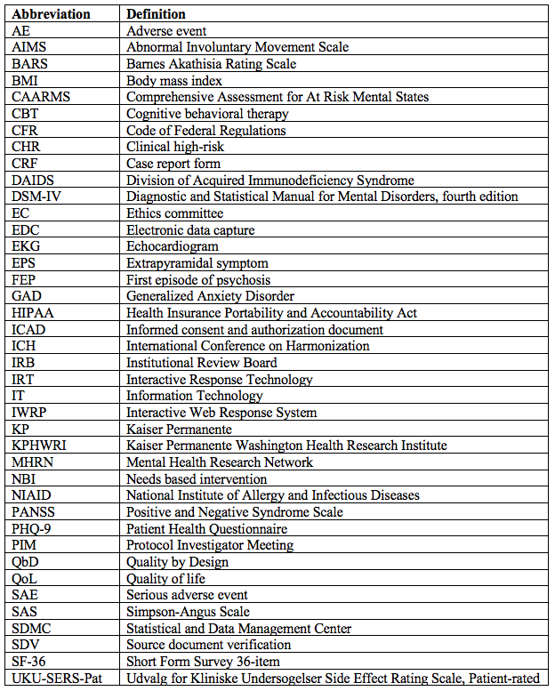

1 Background and Statement of Goals

1.1 Psychotic Disorders are Debilitating and Difficult to Treat

Primary psychotic disorders such as schizophrenia are relatively rare; the global point prevalence of all psychotic disorders is approximately 0.39% while for schizophrenia the prevalence has been estimated at 0.28%. 1,2 However, these conditions are highly morbid and disabling, accounting for at least 1.7% of global disability burden and causing considerably shorter lifespans for those affected.2 A systematic review and meta-analysis of life expectancy studies found schizophrenia conferred an average of 14.5 life years lost compared to unaffected controls.3

Clinical management of psychotic illness is typically complex and challenging. The period preceding full-fledged psychosis, known as the prodrome, often lasts several years and involves increasing psychotic symptomatology including hallucinations, bizarre thought content, and paranoia. Negative symptoms such as anhedonia may also be present. The prodromal period is marked by high levels of depressive and anxious psychopathology, poor functioning, and low quality of life (QoL).4 Social functioning is significantly impacted and can mirror the deficits seen in both first and multi-episode psychotic patients.5

1.2 Benefits of Early Intervention in Psychotic Disorders

Early intervention in the psychotic process, even before an individual meets criteria for a frank psychotic episode, is considered crucial to the long term health and QoL of patients affected by psychosis. Longer duration of untreated psychosis, later age of psychosis onset, greater symptom burden, and poor premorbid adjustment have been identified as factors associated with poor QoL in first episode psychosis.6,7

In addition to improvements in QoL, early intervention treatments for psychosis have been shown to provide psychiatric benefits for patients. A 2010 meta-analysis of first episode psychosis found early intervention led to reductions in hospital admissions, psychotic relapse rates, symptom burden, and treatment disengagement.8

These findings are restricted to individuals who are experiencing their first episode of psychosis (FEP), typically defined as when an individual begins receiving treatment for psychosis or has experienced untreated psychosis for a specified duration (e.g. < 6 months).9 However, a potential implication following from these results in FEP patients is that advancing the intervention window even further upstream that is, before the onset of frank psychosis but after signs and symptoms of the prodrome have arisen may yield benefits of greater magnitude and/or duration than for those who have already developed psychosis. Further, the onset of frank psychosis may be delayed or averted altogether, offering immense benefit at the individual, family, and population levels, particularly if standardized treatments can be reliably implemented in diverse primary care settings.10,11

1.3 Clinical High Risk for Psychosis as a Study Population

Better understanding the etiology of psychotic disorder and developing efficacious treatments aimed at the early pathogenesis of psychosis has been a research and clinical goal for more than two decades. A paradigm for identifying those at “clinical high risk” for psychosis (CHR) – that is, after prodromal symptoms have arisen but before the development of full psychosis – has taken shape over this time.12

The CHR state, also called “ultra high risk”, has been operationalized with several validated interviews, including the Comprehensive Assessment for At Risk Mental States (CAARMS)13 which includes three classifications of CHR: 1) “attenuated psychosis”, or subthreshold severity of psychotic symptoms several times a week for more than 1 week; 2) “brief limited intermittent psychotic symptoms”, or high severity psychotic symptoms at high frequency for less than 1 week; or 3) “vulnerability” or “genetic risk and deterioration”, defined as having schizotypal personality disorder or a first degree relative with psychotic disorder and a recent decrease in functioning. The initial validation studies of the CAARMS have shown that those classified as CHR by CAARMS criteria will transition to psychosis over a 1-year period at rates several hundred times those in the general population.13 Other measures have been developed to assess risk for transition to psychosis but most are validated against the CAARMS.

1.4 CHR Clinical Trials have had Low Power and Short Follow Up

The CAARMS offered a reliable and effective method to enroll individuals at high risk of transition to psychosis in clinical trials, and a wave of diverse research projects followed its publication, investigating the efficacy of psychosocial interventions such as cognitive behavioral therapy (CBT), antipsychotic medications, and nutritional supplements.14,15 No individual trial provided conclusive evidence of benefit, however, and study samples proved to be highly heterogeneous with respect to psychosis transition rates in control groups, in part because CHR definitions and psychosis outcome measures are not consistent across studies. Control transition rates ranged from 7-37% across 11 studies published between 2002 and 2012.14

Many CHR investigations have been hampered by lower than expected event rates and low participant retention rates, thus limiting statistical power. Furthermore, few studies have maintained follow-up beyond 12 months, despite a growing recognition that the CHR state confers heightened psychosis transition risk for at least 2 years. Thus, the long term efficacy and durability of any particular treatment is uncertain. Meta-analytic investigations have identified CBT and some second generation antipsychotics as potentially promising psychosocial intervention.15

There is substantial need for sufficiently powered randomized controlled trials to investigate reducing psychosis transition rates and delaying the onset of FEP.

1.5 Risk Enrichment

Psychosis is a rare occurrence and thus is difficult to sample effectively. As noted, transition to psychosis rates for identified CHR populations vary substantially across the published RCTs, with some control transition rates as low as 7% -- still many fold more than would be expected in a general population sample, but low enough to hinder statistical power.

Recent work has indicated that the predictive validity of CHR identification depends on the incoming risk profile of the patients sampled. Since transition to psychosis is a relatively low incidence event, a sample with low pre-test risk (e.g. all mental health outpatients or self-referrals to a clinical trial) significantly dilutes predictive power compared to a sample with high pre-test risk (e.g. patients seeking help for subthreshold psychotic symptoms or psychological disorganization).12 Thus, our proposed project will focus on referrals from clinical care providers who have identified low-level or subthreshold psychotic symptoms in patients.

Additionally, the proposed study will modify CAARMS criteria to enroll CHR individuals at highest risk of transition to psychosis. Previous literature has demonstrated that affective and cognitive disturbance and disorganization are better predictors of psychosis transition than other elements of the prodromal experience and that “vulnerability” confers less risk of psychosis transition in the absence of other signs.16,17 Narrowing the classification CHR has the potential to increase transition rates. Furthermore, sampling the highest risk amongst CHR individuals -- which we are terming “severe CHR” -- allows for investigation into those who stand to receive greatest benefit from effective CHR intervention.

1.6 Quetiapine for Severe CHR Individuals

Quetiapine is a broadly used second generation antipsychotic that shows low rates of extrapyramidal symptom development. Despite its common use in primary care settings, it has not been investigated as a putative prevention method for CHR individuals. Quetiapine shows similar efficacy and treatment persistence to other second generation antipsychotics. In addition, while it is not indicated for anxiety, several RCTs have demonstrated the effectiveness of quetiapine in reducing anxiety when compared to placebo18 and quetiapine has received Food and Drug Administration (FDA) approval as an adjunctive treatment for major depressive disorder. Thus, quetiapine may benefit CHR individuals by addressing both psychotic symptoms and the high levels of anxious and depressive psychopathology typically found in the prodrome.

Our proposed trial has several key strengths. First, we will leverage a partnership with the expansive Kaiser Permanente Healthcare Network to recruit sufficient numbers of CHR individuals to definitively test the efficacy of intervention on the primary endpoint. In addition, this partnership will promote participant retention and intervention adherence by embedding research activities in the mental health clinics where potential participants are seeking mental health treatment. We will target recruitment on risk enriched populations (i.e. help-seeking individuals), and we will further risk enrichment by selecting participants with high disorganization scores on the CAARMS. Finally, the large, national dataset generated from this trial will be fertile ground for many future examinations, including identifying predictors of psychosis transition, comparing outcomes for transitioned vs non-transitioned participants, and providing deeper characterization of the clinical high risk for psychosis state.

1.7 Statement of Goals & Objectives

We propose a well-powered, comprehensive assessment of the efficacy of quetiapine when combined with needs based intervention for CHR individuals. The broad goal of the project is to test the efficacy of a widely used antipsychotic medication, quetiapine, in reducing psychosis transition rates and in supporting improvements in QoL for those at CHR for psychosis. To ethically conduct this project, quetiapine will be examined as an adjunctive to needs based intervention (NBI) while the control group will receive placebo + NBI. First conceived by the group that initially defined the CHR state, NBI includes the following components. (a) needs-based supportive psychotherapy for problems with, for example, relationships, work or family; (b) case management for resolving issues with education, housing or employment; (c) brief family psychoeducation and general advice; (d) different types of medications other than antipsychotics; and (e) clinical monitoring alone or coupled with crisis management.

The study objectives are as follows:

1. Examine the efficacy of quetiapine + NBI compared to placebo + NBI in reducing transition to psychosis rates for severe CHR individuals in the Kaiser Permanente Healthcare Network.

*We hypothesize that a lower proportion of participants in the quetiapine + NBI arm will transition to psychosis when compared to the placebo + NBI group.*

1. Examine the efficacy of quetiapine + NBI compared to placebo + NBI in improving quality of life for severe CHR individuals in the Kaiser Permanente Healthcare Network. We hypothesize that participants in the quetiapine + NBI group will report greater QoL across follow up than participants in the placebo + NBI group in the Kaiser Permanente Healthcare Network.

*We hypothesize that a lower proportion of participants in the quetiapine + NBI arm will transition to psychosis when compared to the placebo + NBI group.*

2. Study Population

Individuals identified as severe clinical high-risk (CHR) for psychosis will be eligible to participate in this study. Participants will be selected for the study according to the criteria in Section 2.1 and 2.2. They will be recruited, screened, and enrolled as described in Section 2.3. Issues related to participant retention and withdrawal from the study are described in Sections 2.4 and 2.5, respectively.

2.1 Inclusion Criteria

Participants are eligible to be included in this study only if all of the following criteria applied:

* Participants aged between the ages of 18 and 35 years.
* Participants identified as CHR with the Comprehensive Assessment of At-Risk Mental States (CAARMS) who demonstrate moderate to severe disorganized speech or behavior, cognitive disturbance, or affective disturbance.
* Participants who have no prior diagnosis of FEP.
* Participants are willing and are able to complete the study.
* Participants who are willing and able to sign the informed consent as described in Appendix I.
* Participants who meet physical health parameters (QTc ≤450 for men, ≤470 for women on screening echocardiogram [EKG])

2.2 Exclusion Criteria

Participants will be excluded from this study if any of the following criteria applied:

* Individuals who have been diagnosed with active psychosis.
* Individuals with previous or current quetiapine usage
* Individuals with Intellectual disability (defined as intelligence quotient  
  less than 70).
* Individuals with severe substance use disorder (including but not limited to alcohol and cannabis)
* Individuals with active suicidality.
* Individuals with contraindications to quetiapine usage
* Individuals who refused to participate in this study.
* Individuals who have to take medication that should not take with quetiapine.
* Individuals who do not understand English or Spanish.
* Female individuals who are pregnant or during breastfeeding

2.3 Recruitment Process

Participant recruitment will leverage the integrated Kaiser Permanente (KP) health system to broadly recruit from KP behavioral and mental health programs across the country. The investigative team has established a promising working relationship with the Kaiser Permanente Washington Health Research Institute (KPHWRI). The national Kaiser system includes over 12 million members treated at 39 hospitals and 700+ medical offices, and KP has a long history of conducting rigorous and ethical health research. Health system members are often active participants in research studies and providers have familiarity with discussing research studies with patients.

The proposed study will be coordinated from the KPHWRI with multiple sites across the KP network: 1) Washington Puget Sound; 2) Baltimore; 3) Washington, DC; 4) Atlanta; 5) Northern California; and 6) Southern California. The Northern California site will consist of multiple sub-sites including Greater San Francisco, Greater Southern Alameda, East Bay, Sacramento, South Sacramento, and Fresno. The Southern California site will consist of multiple sub-sites including Metro Los Angeles, Orange County, Tri-Central Area, West Ventura/Valleys, San Diego County, and Kern County. In totality, these sites cover dozens of behavioral and mental health facilities, both inpatient and outpatient, with catchment areas covering roughly 36 million people.

One major pathway for recruitment will be provider referral. Care providers across sites will interface with study staff to identify and refer participants who are seeking help for psychopathology and who indicate any severity of psychotic symptomatology. The following services will be approached and asked to engage in the research project as referrers:

* Primary care clinics
* Outpatient psychology/psychiatry services (including psychiatrists, psychological therapists, counselors)
* Emergency departments
* Social work services and case managers

Electronic medical record screening will also be employed to support recruitment. Individuals within the KP system with a diagnosis of schizophrenia or non-affective psychosis (schizophreniform disorder, schizoaffective disorder, brief psychotic disorder, or psychosis not otherwise specified) will be identified and sent a letter informing them of the study and encouraging them to refer first degree family relatives.

All referrals will be directed to the research study team for screening. A first pass screening will provide potential participants with greater detail on study purpose and procedures and confirm that referrals meet basic eligibility criteria. A second pass screening for interested individuals will include EKG, assessment of psychotic symptoms with the CAARMS and more in-depth screening of psychopathology (e.g. suicidality, substance use). Electronic medical records will be screened for contraindications to quetiapine or evidence of other exclusions. Those found eligible at second pass will be invited to complete informed consent. Potential participants will have the opportunity to ask questions about the study with a medical doctor on the study team. They will also be encouraged to discuss participation with their clinical provider.

The research study team will conduct outreach to connect with referring care providers regarding the research trial in order to optimize patient referral. The study team will provide outreach materials with pertinent trial information designed specifically for doctors and mental health providers. The extensive Kaiser Permanente health network will be used to facilitate the dissemination of information about the research trial.

2.4 Participant Retention

Once a participant enrolls in this study, the study site will make every effort to retain them for 36 months of follow-up in order to minimize possible bias associated with loss-to-follow-up. We are aiming for a 70% retention rate. The following protocols will be in place to improve participant adherence to the study:

* Provide a detailed introduction of this study and the importance of completing this study to the participants and to others who may be at risk for psychosis, including reminders of this information periodically throughout the study
* Express genuine appreciation for participant decisions to volunteer time
* Alert the participant to the negative impact that incomplete capture of outcomes has on clinical trial integrity and credibility.
* Collect detailed information at the study screening visit, and actively review and update the information at each follow-up visit.
* Use appropriate and timely visit reminder mechanisms.
* Immediate and multifaceted follow-up on missed visits.
* Mobilization of trained research assistants to complete in-person contact with participants at their homes and/or other community locations, and multifaceted follow-up on missed visits.
* Female patients of childbearing potential must agree to use an effective method of birth control to avoid contraception during the study period.

2.5 Participant Withdrawal

Participants may voluntarily withdraw from the study for any reason at any time by withdrawing informed consent. However, retention efforts will be made to avoid loss to follow-up. The Investigator may withdraw participants from the treatment intervention in order to protect their safety after consultation with the Protocol Chair, DAIDS Medical Officer, SDMC Protocol Statistician, and CORE Protocol Specialist. If the study participant needs hospitalization because they develop FEP, the participant will be withdrawn from treatment, and the withdrawal will count as an event. However the participant will remain in the study for follow up. Participants can be withdrawn from the treatment intervention if they develop one of the exclusion criteria during the intervention, if informed consent is withdrawn, or in case of non-compliance or safety concerns for the patient.

Criteria for participant removal by the PI should be outlined in the protocol and/or IRB application. Potential reasons for removal should be described in the informed consent and authorization document (ICAD) for studies in which consent and/or assent is required.

If the participant withdrawals from the study, his/her data must be anonymized at the end of the study. This anonymization is not done if the participant gives his/her explicit consent. For the protection of the withdrawn participant he/her has to be offered follow-up care.

3 Study Design

3.1 Assessments

Each participant will attend a clinical visit after screening to finish baseline assessment at the clinic (see Appendix I Study Schema for overview). At baseline, participants will complete anthropometric assessments (e.g weight, BMI, waist circumference), vital sign assessment (e.g. heart rate, blood pressure), and blood draws for metabolic and thyroid panels. If the baseline visit is within 4 weeks of the screening EKG, the EKG will not be repeated at baseline and the screening data will be retained as study data. Self-report questionnaires will be completed including the 36-item Short Form Health Survey (SF-36) to measure quality of life, the 9-item Patient Health Questionnaire (PHQ-9) for depression, the 7-item Generalized Anxiety Disorder scale (GAD-7) to assess anxiety. A trained clinician will administer the Positive and Negative Syndrome Scale (PANSS) to rate symptoms of psychosis. People who take antipsychotic medications might gain or lose weight at the starting stage of treatment, therefore it is necessary to do multiple assessments to prevent serious adverse events from the side effects of quetiapine.

The baseline assessment is a record of the participant’s various metrics, and assessments will be repeated at variable follow-up points to ensure participants’ safety and proper collection of endpoint data during the 3-year study. As a measurement of the study’s primary endpoint, the PANSS will be repeated monthly. Adherence will be assessed with pill counting on a monthly basis. Adverse events will be collected at all visits to ensure close safety monitoring throughout the study. Anthropometrics and serum panels will be repeated monthly for the first three months after participant enrollment. After 3 months, these assessments will be reduced to occur once every 3 months. Self-report surveys PHQ-9, GAD-7 and the SF-36 - will be assessed every 3 months, though participants who report active suicidality during the study will be considered for withdrawal.

Table 1. Assessment Schedule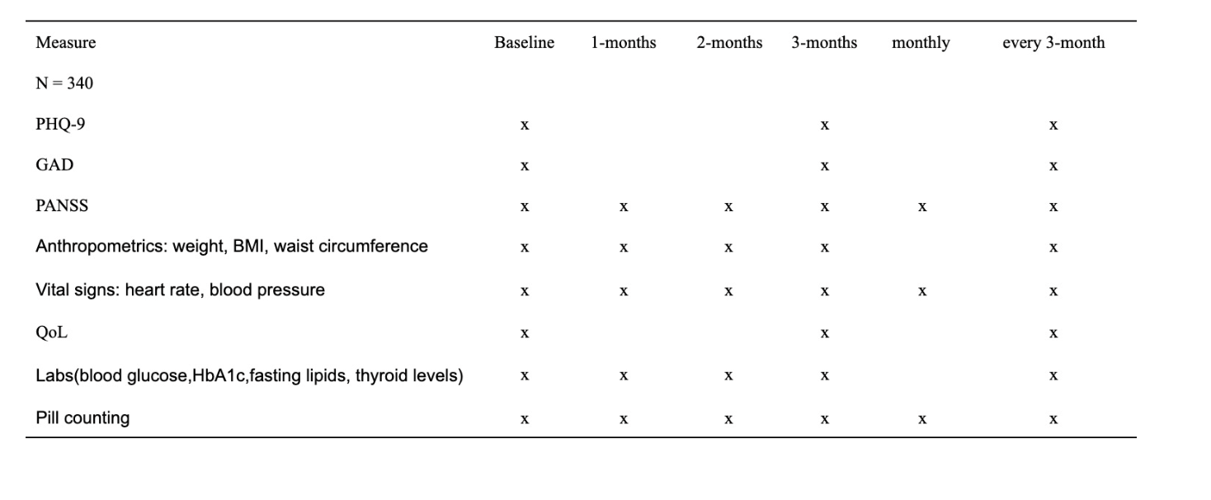

Routine electronic medical record review will also be performed as a part of study conduct. This review will check for participant inpatient hospitalizations due to psychosis, which will count as a primary endpoint event. Participants who are hospitalized due to psychosis will have the option to continue attending study visits to maintain follow-up data collection on comorbid factors and the secondary endpoint, QoL, but will no longer receive the intervention medication.

3.2 Randomization

Participants will be randomized at a 1:1 ratio of quetiapine + NBI to placebo + NBI. Randomization will be stratified by clinical site and blocked by time. No other stratifiers will be utilized given the large sample size of the project. Randomization will occur at the site level. A Web-based randomization tool will be developed for use by study coordinators. This tool will communicate participant randomization assignment to KP pharmacies responsible for dispensing study medication.

3.3 Intervention

The investigated medication for individuals with CHR for psychosis will be low dose quetiapine (200 mg per day), in the form of immediate release oral tablet. Since our participants haven’t been diagnosed with FEP in the past, participants need to start with the dose of quetiapine of 25-50 mg for the first day, and then increase to 100 mg for the second day, and 200 mg starting from the third day to let the participant gradually get used to the medication. All the quetiapine that participants are prescribed will come from the same brand, Seroquel. Supplies will be purchased from the KP pharmacy system. Participants will be instructed to take quetiapine around at the same time every day and strictly follow the directions on the prescription label. Participants who are taking other medications will get their usual treatment.

3.4 Controls

Controls in this study are the placebo that appears as identical as possible to the test treatment with respect to physical characteristics such as color, weight, taste and smell, but that does not contain quetiapine. Participants assigned in the control group will follow the same instruction as participants in the intervention group. Participants in the control group will be required to provide the same study measures as participants in the intervention, including undergoing health exams, completing questionnaires. Participants in the control group will also get their usual treatment if they have other physical or mental diseases.

3.5 Adherence assessment

The medication adherence will be assessed through counting the number of remaining pills every month when participants return to the clinic or facility for re-assessment. Pill count is a simple method that calculates the number of doses that have been taken between appointments, and compares it with the total number of doses that the patient has received. We aim for greater than 50% adherence for each participant.

3.6 Toxicity management

Quetiapine is an atypical antipsychotic drug that, at toxic doses, has severe adverse effects such as coma, respiratory depression, and hypotension. With participants coming into the clinic or research facility monthly and lab works regularly, their safety is being closely monitored. Study participants will be provided a 24-hour telephone number and instructed to contact the study clinician to report any serious or severe AEs they may experience, except for life-threatening events, for which they will be instructed to seek immediate emergency care. Adverse events will be reviewed monthly by the investigative team and every 6 months by the DSMB.

3.7 Clinical Management of Pregnancy

Participants who are pregnant will be excluded from the current study, if participants already in the study have a planned pregnancy or pregnant unplanned should inform doctors or clinicians.

3.8 Concomitant medication

Some medications interact with quetiapine, and may lead to adverse events. Therefore those participants who have to take medication that have severe interactions with quetiapine will be excluded from the study. In addition to prescribed and over-the-counter medications, such as vitamins, herbal remedies, and other traditional preparations will be recorded. Questionnaires like medication taken will also be delivered as study processes to ensure the validity of our study and participants’ safety.

The risks of using Seroquel in combination with other drugs have not been extensively evaluated in systematic studies. Given the primary CNS effects of Seroquel, caution should be used when it is taken in combination with other centrally acting drugs. Seroquel potentiated the cognitive and motor effects of alcohol in a clinical trial in subjects with selected psychotic disorders, and thus participants will be instructed that alcoholic beverages should be avoided while taking Seroquel.

4 Safety Monitoring and Adverse Event

4.1 Safety monitoring

Close cooperation between the Protocol Chair(s), study site Investigator(s), NIAID Medical/Program Officer, CORE Protocol Coordinator, SDMC Biostatistician, and other study team members will be necessary in order to monitor participant safety and respond to occurrences of toxicity in a timely manner.

4.1.1 Clinical Monitoring

This project will involve close engagement with clinical teams across the KP health system landscape. If study staff are unable to interface with participants, the KP clinic or hospital where the participant regularly receives care will be advised to monitor certain health issues as an assurance of participant safety while taking this drug. These issues include:

* Blood sugar.
* Cholesterol.
* Weight.
* Mental health and behavioral problems.
* Thyroid hormone levels.

4.1.2 Safety Monitoring

Safety monitoring will occur on a monthly basis and will consist of both patient reported symptoms monitoring as well as observation and examination by the clinical research team.

Part I: Udvalg for Kliniske Undersogelser Side Effect Rating Scale, Patient rated (UKU-SERS-Pat)

The UKU-SERS-Pat is a patient-report survey regarding the side effects for drug treatments in schizophrenia and has been clinically validated against clinician assessment [Lindstrom, et al. 2001]. It consists of 10 questions regarding psychic side effects (e.g. concentration difficulties, memory issues, changes in sleep), 9 questions regarding neurological side effects (e.g. dystonia, rigidity, tremor), 11 questions on autonomic side effects (e.g. salivation changes, nausea/vomiting, GI issues, palpitations), and 16 questions on other side effects (including questions on rash, weight changes, period changes, and sexual dysfunction). There are 46 questions in total. The questions are available in the appendix as Supplemental Material 1. Most of the questions are on a 4-point Likert scale (e.g. Not at all, A little more than usual, More than usual, Much more than usual) corresponding to degree of severity (graded 0, 1, 2, 3). In addition to the ratings of individual items, the scores are summed as sub-scores for each of the four subgroups (Psychic, Neurological, Autonomic and Other side effects) occurring in both sexes. A total sum of the ratings for all items is also calculated in order to measure the Total Score.

Part II: Barnes Akathisia Rating Scale (BARS)

The BARS was developed for assessment of drug-induced akathisia or restless movements. It comprises three items rating the severity of the restless movements, the subjective awareness of restlessness, and any distress associated with the akathisia. The questions are available in the appendix as Appendix IV Each of the three items (for objective and subjec- tive awareness/distress) is graded on a 4-point scale (0, 1, 2, 3) and summed to yield a total score ranging from 0 to 9. In addition, there is an item for rating global severity (Global Clinical on a 6-point scale (0, 1, 2, 3, 4, 5) where 0 indicates an absence of akathisia and 6 indicates severe akathisia with constant restlessness associated with intense distress.

Part III: Abnormal Involuntary Movement Scale (AIMS)

The AIMS is a 12-item clinician-rated scale to assess the severity of dyskinesias (with a focus on orofacial movements and extremity and truncal movements) in patients taking neuroleptic medications such as antipsychotics. Additional items assess the overall severity, incapacitation, and the patient’s level of awareness of the movements, as well as the distress associated with them. The questions are available in the appendix as Appendix V. Items are scored on a 5-point scale (0, 1, 2, 3, 4) with 0 representing no symptoms and 4 representing severe symptoms. The scale also provides a total score (summing the scores for items 1 through 7) or item 8 can be used in isolation as an indication of overall severity of symptoms.

Part IV: Simpson-Angus Scale (SAS)

The SAS was developed to assess extrapyramidal symptoms, specifically the parkinsonism, in patients taking neuroleptics/antipsychotics. It consists of a 10-item scale with items regarding gait (hypokinesia), rigidity, glabella tap, tremor, and salivation. The questions are available in the appendix as Supplemental Material 4. The patient is examined by a clinical observer who then grades the patient based on symptoms. Items are scored on a 5-point scale (0, 1, 2, 3, 4) with 0 representing normal and 4 representing significant symptoms.

4.2 Adverse Event

An adverse event (AE) is any untoward medical occurrence in a patient or clinical investigation subject administered a pharmaceutical product and which does not necessarily have a causal relationship with this treatment.

Study participants will be provided a 24-hour telephone number and instructed to contact the study clinician to report any AEs they may experience, except for life-threatening events, for which they will be instructed to seek immediate emergency care. Where feasible and medically appropriate, participants will be encouraged to seek evaluation where the study clinician is based, and to request that the clinician be paged or otherwise contacted upon their arrival. With appropriate permission of the participant, whenever possible records from all non-study medical providers related to AEs will be obtained and required data elements will be recorded on study case report forms. All participants reporting an AE will be followed clinically, until the AE resolves (returns to baseline) or stabilizes.

Study site staff will document on study case report forms all AEs reported by or observed in enrolled study participants regardless of severity and presumed relationship to study product. All AEs will be graded using the DAIDS Table for the Grading Severity of Adult and Pediatric Adverse Ex- periences (also referred to as the “Toxicity Table”). The investigator or designee will assess the relationship of all AEs to the study product based on the Investigator’s Brochure, Package Insert, DAIDS Drug Risk List, and his/her clinical judgment.

4.3 Serious adverse event

Serious adverse event (SAE) will be defined per U.S. Code of Federal Regulations (CFR) 312.32 and International Conference on Harmonization (ICH), “Good Clinical Practice: Consolidated Guidance” (E6) and “Clinical Safety Data Management: Definitions and Standards for Expedited Reporting” (E2A), as AE occurring at any dose that:

* Results in death
* Is life-threatening
* Results in persistent or significant disability/incapacity
* Is a congenital anomaly/birth defect
* Requires inpatient hospitalization or prolongation of existing hospitalization

This includes important medical events that may not be immediately life-threatening or result in death, or hospitalization but may jeopardize the patient or may require intervention to prevent one of the outcomes listed above.

5 Statistical Consideration

5.1 Review of the Study Design

The study is a 2-arm, double-blind, placebo-controlled randomized trial with 1:1 allocation of treatment to control.

5.2 Endpoints

The study is interested in whether low-dose quetiapine can decrease the incident rate of transiting to psychosis in severe CHR participants. For each participant, the time to develop FEP will be recorded. If participants are diagnosed with FEP during the 36-months study time, the time of diagnosis also will be recorded. Participants who do not transit to FEP at the end of 36-months will be recorded as censored. Participants will be asked to complete the quality of life questionnaires (SF-36) at every three-months from study enrollment to research quetiapine’s effect on improving the quality of life of participants.

5.2.1 Primary Endpoint

Consistent with the primary study objective of researching quetiapine’s effect on the incident rate of FEP, monthly follow-up sessions will be conducted to the patients to track when the participants have transited to the FEP. The transition status will be determined by the results of PANSS which participants will take during the follow-up visits. Participants who have a PANSS score that is higher than 58 will be defined as transited to the FEP. The time when the participant transit to the FEP will be recorded. For participants who do not transit to the FEP in 36 months will be recorded as censored. Transition to FEP will also be counted in the case where participants undergo inpatient hospitalization for psychotic symptoms.

5.2.2 Secondary Endpoint

Consistent with the secondary study objective to research quetiapine’s effect on increasing the quality of life of patients, for each time SF-36 is given, the score of participants will be recorded.

5.3 Accrual, Follow-up, and Sample Size

The sample size is driven by the total number of cases of transition to FEP to demonstrate the effect of low-dose quetiapine in preventing transition to psychosis in severe clinical high-risk individuals. Under the assumption of the quetiapine proportional hazards over time and with 1:1 randomization to quetiapine: placebo, a total of 66 transitions to FEP events will provide 80% power to detect a 50% reduction in hazard rate, rejecting the null hypothesis H0: low-dose quetiapine has no efficacy, with 1 interim analysis at 50% of the total events using a 1-sided O’Brien-Fleming boundary for efficacy. Under the assumption that the placebo group will have 40% incident rate, 20% in the treatment group, and 35% drop rate in a 36-month period, we estimate that up to approximately 340 participants need to be randomized with the adjustment that has been made to adjust the expected level of missing data.

5.4 Random Assignment

Approximately 340 participants will be randomly assigned in a 1:1 ratio to receive either low-dose quetiapine or placebo pills. The Interactive Web Response System (IWRP), a technology under Interactive Response Technology (IRT) will be used in this study to randomize patients in a blinded manner. Patients assigned to the treatment group will get capsules containing 200 mg quetiapine per day. Patients assigned to the placebo group will get matching placebo capsules. The capsules are identical in appearance.

5.5 Blinding

The study is a double-blinded study. After randomization, the participants, study site investigators, study staff, or site monitors will not be aware of the study intervention assignments. Limited unblinded responsibility will be permitted as part of regular safety review performed by the Data and Safety Monitoring Board (DSMB) at the written request of the DSMB. The DSMB will document rationale for unblinding.

5.6 Data Analysis

5.6.1 Primary Data Analysis

For our primary study objective, our statistical analysis will include the Kaplan-Meier survival curve to estimate the incidence rate of the transition to FEP. The time to events method(survival analysis) is used in the primary analysis. The primary analysis will be performed after we ensure 66 events of transiting to FEP. Cox proportional hazards model will be used to calculate the relative risk comparing the transition rate to FEP in the severe clinical high-risk population who take quetiapine with those who do not. The log- rank test will be applied to test the efficacy of quetiapine under the null hypothesis that quetiapine has no effect on the prevention of transition to FEP. The test will perform at the 2-sided significance level of 0.05(α=0.05). The study will be considered positive at the primary analysis when a total of 66 events have been observed and if the two-sided p-value will be less than 0.05.

There is one interim analysis planned in this study, which will be performed when approximately 50% (event number = 33) of the target total number of transitions to FEP across the two treatment groups have been observed respectively. The primary objective of the interim analysis is to detect reliable evidence that the low-dose quetiapine has an effect of 50% reduction in the incident rate. The O’Brien-Fleming approximation spending function is used for cal- culating efficacy bounds and to preserve the 2-sided 0.05 false-positive error rate over the interim analysis, related to the null hypothesis. The study will be considered positive at the interim analysis if the p-value for rejecting the null hypothesis is less than 0.088 based on the O’Brien-Fleming approximation. This number is calculated by the gsDesign package installed in the R language.

Table 2: Analysis Schedule

|  |  |  |  |
| --- | --- | --- | --- |
| Information Fraction(% of total # cases) | Number of cases | Nominal Alpha | Z-value |
| IA 50% | 33 | 0.041 | 2.37 |
| Primary Analysis 100% | 66 | 0.051 | 1.68 |

5.6.2 Secondary Data Analysis

For our secondary study objective, we will include the descriptive statistics of the SF-36 scores in different times of the two groups. We will use paired t-test to compare the changes in SF-36 scores from baseline to the ends of the study between the two treatment arms with the null hypothesis that the quality of life is no difference in the two groups. The test will perform at the 2-sided significance level of 0.05(α=0.05), robust standard error will be used at 95% of confidence level.

6 Data Monitoring

6.1 Purpose

The purpose of this document is to specify all study specific monitoring requirements for Protocol that ensure that the clinical sites comply with the study protocol and regulatory requirements.

6.2 Study Roles and Responsibilities

Kaiser will provide a third-party data monitoring committee to be responsible for the monitoring of this study.

6.3 Tools and Processes

6.3.1 Study data

This study will use direct data entry of clinical trial data. This process allows a clinical study site to perform direct data entry of original data into electronic data capture (EDC) at the time of the subject’s office visit, and for the original data to be stored in PDF format in the access-controlled data repository, access to which is controlled by the clinical Investigator or designee. These original data are stored in the access-controlled data repository prior to the data being transmitted to the EDC database.

6.3.2 EDC Monitoring Module

Monitors will record all monitoring reports in an online EDC system.

6.4 Source documents

1. Source data/records contain all the information necessary for the reconstruction and evaluation of the study. Source data/records are 1) original records, 2) certified copies of original records, 3) observations, 4) laboratory reports, 5) paper Case Report Forms (CRFs) and/or data sheets. In addition, with the use of direct data entry, the PDFs maintained in access-controlled data repositories serve as original records. The EDC system and access-controlled data repository also support a process for certifying copies of records originally captured on paper.
2. At the time of the first monitoring visit or during the initiation visit, the source of original data, whether it is being collected in electronic or paper format, will be identified for each site.

6.5 Monitoring

Onsite monitoring visits will focus on assuring that the clinical site understands and is following the protocol, reviewing completeness and accuracy of Informed Consent Forms, drug supply reconciliation, risk-based source document verification (SDV) of original records, and other issues that may occur during the course of the clinical trial.

Central monitoring will focus on the assessment of 1) the “reasonableness” of data entered into EDC system and 2) data quality management metrics

7 Human Subject Considerations

7.1 Ethical Review

This protocol and the informed consent form(s) contained in Appendix — and any subsequent modifications — will be reviewed and approved by the Protocol Review Committee and DAIDS Prevention Science Review Committee with respect to scientific content and compliance with applicable research and human subjects regulations. The protocol, site-specific informed consent form, participant education and recruitment materials, and other requested documents — and any subsequent modifications — also will be reviewed and approved by the ethical review bodies responsible for oversight of research conducted at the study site.

All of our participants are recently identified as having severe clinical high-risk (CHR) for psychosis. We are testing our hypothesis that taking a low-dose of quetiapine (200mg) adjunctive to standard of care (needs based intervention [NBI]) will reduce transition to psychosis rates for individuals identified as severe CHR. Control participants will receive NBI plus placebo .

Therefore participants randomized to the control group will receive standard of care and will not be harmed by not receiving the intervention. Subsequent to initial review and approval, the responsible IRBs/ECs will review the protocol at least annually. The Investigator will make safety and progress reports to the IRBs/ECs at least annually, and within three months of study termination or completion.

These reports will include the total number of participants enrolled in the study, the number of participants who completed the study, all changes in the research activity, and all unanticipated problems involving risks to human subjects or others. In addition, all open DSMB reports will be provided to the IRBs/ECs. Study sites will submit documentation of continuing review to the DAIDS Protocol Registration Office, in accordance with the current DAIDS Protocol Registration Policy and Procedure Manual.

7.2 Informed Consent

Written informed consent will be obtained from each study participant. Each study site is responsible for developing a study informed consent form for lo- cal use, based on the template in Appendix VI, that describes the purpose of the study, the procedures to be followed, and the risks and benefits of participation, in accordance with all applicable regulations.

The study site also is responsible for translating the template form into Spanish and verifying the accuracy of the translation by performing an independent back-translation. Participants will document their provision of informed consent by signing their informed consent forms, after having ample opportunity to ask questions of research staff and discuss with family, clinical professionals, or trusted confidants.

Study staff obtaining consent will be appropriately knowledgeable, trained, and certified to answer common questions about medication side effects. Staff will be trained to utilize lay language to communicate study complexities. Consent comprehension will be assured with the teach back method. Participants will be provided with a copy of their informed consent documentation if they are willing to receive them.

7.3 Risk

Low to moderate grade side effects are expected in the treatment group (quetiapine + NBI), particularly at the initiation of treatment. Participants will be advised of both common, mild side effects and serious rare side effects. Participation in the study will be noted in participant medical records to alert Kaiser-based medical providers to potential side effects and drug interactions. Treatment-related adverse events may be less common than rates seen in clinical populations due to the low dose of quetiapine proposed in this study. Though quetiapine does not have strict contraindications, several conditions require special precautions and more intensive medical management. Thus all participants will be thoroughly screened prior to enrollment to exclude for the following conditions:

* Current pregnancy or breastfeeding
* Diabetes Type I or II
* Pre-diabetes
* Prolonged QT interval

Prior to treatment initiation, all participants’ available medical records will be carefully analyzed by a study-supported clinical team to avoid drug combinations that may cause severe adverse events. A range of common side effects are expected and will be recorded to evaluate the safety and feasibility of low-dose quetiapine in CHR individuals.

Common side effects of quetiapine (≥ 5% incidence) include:

* Daytime drowsiness
* Increased sleep hours
* Dizziness
* Dry mouth
* Constipation
* Serum glutamic pyruvic transaminase elevation
* Weight gain
* Dyspepsia/indigestion
* Tachycardia
* Agitation

Less common side effects (≤ 5% incidence) include:

* Rash
* Somatic pain
* Gastroenteritis
* Pharyngitis
* Rhinitis
* Decreased sexual arousal
* Decreased orgasm
* Gynecomastia
* Urinary hesitancy
* Incontinence or nocturia
* Galactorrhea
* Sialorrhea
* Akathisia
* Akinesia
* Insomnia
* Menstrual irregularities
* Decreased sex drive

Quetiapine may induce detrimental cardiometabolic effects including hy- perlipidemia, hyperglycemia, or arrhythmia. Participants will undergo regular and frequent electrocardiographic monitoring during the first phase of the study with less frequent monitoring as the study progresses. Regular and fre- quent serum samples will be obtained for full metabolic analysis throughout study participation.

The rate of extrapyramidal symptom (EPS) development with atypical antipsychotics such as quetiapine is lower than first-generation counterparts, and quetiapine is considered to have the lowest rate of EPS development of all atypical antipsychotics. However, these complications may still arise. Participants will regularly and frequently complete self-report rating scales assessing EPS such as the Udvalg for Kliniske Undersøgelser scale.

7.4 Benefits

Although there are no direct benefits promised to participants in this study, participants and others may benefit in the future from information learned from this study. Participants may garner the following benefits:

* The low-dose quetiapine may be effective in reducing the probability of participants transiting to the FEP.
* The low-dose quetiapine may be effective in improving the quality of life of participants.
* A baseline (Day 1) evaluation including physical examination events will be conducted to the participants.
* Monthly follow-up sessions will be conducted to the participants, including safety and symptom surveillance
* Contributing to the prevention of the severe clinical high-risk state of FEP population transiting to the FEP.

7.5 Incentives

This research study is fully voluntary. Participants will be reimbursed at each study visit for time spent participating based on the following schedule: enrollment baseline visit - $100; 3-month visits - $80; each year - $100. A participant who finishes all visits will get a total of $850.

7.6 Confidentially

All laboratory specimens, reports, study data collection, process, and administrative forms will be identified by a coded number only to maintain participant confidentiality. All local databases will be secured with password- protected access systems. Forms, lists, logbooks, appointment books, and any other listings that link participant ID numbers to other identifying infor- mation will be stored in a separate, locked file in an area with limited access. Participant’s study information will not be released without the written permission of the participant, except as necessary for monitoring by the NIAID and/or its contractors; representatives of the SDMC, the US Food and Drug Administration, other government and regulatory authorities, and/or site IRBs/ECs.

7.7 Study Discontinuation

The project DSMB may recommend study discontinuation based on safety review. The study also may be discontinued at any time by NIAID, the treatment/product manufacturer, the US Food and Drug Administration, other government or regulatory authorities, or site IRBs/ECs.

8 Facilities, Resources and Equipment

This is a prospective multicenter randomized controlled trial that will assess the efficacy of a medical intervention (quetiapine) in the prevention of first episode psychosis (FEP) in very high-risk individuals. The study will be reviewed by the Kaiser Permanente (KP) institutional review board for each regional health system and all participants will sign informed consent. This research study will utilize the research infrastructure at KP, including the Kaiser Foundation Research Institute, as well as the collaborative Mental Health Research Network (MHRN), of which Kaiser makes up a majority of participating health systems.

The multidisciplinary team will include expert clinical researchers and clinicians in the areas of Psychiatry, Pharmacy, Social Work, and Biostatistics. Before the start of the clinical trial, all site coordinators and study researchers will be trained in the conduct of all study outcome and adverse event monitoring measures.

KP is able to provide local clinic space for the conduct of research stud- ies, as well as local laboratory services for all study lab draws in order to minimize patient travel/inconvenience and optimize study retention. All investigators and staff will be provided with up-to-date desktop computers that are maintained by the KP IT team, which specializes in the IT needs unique to the clinical research environment, including overseeing secure data transfer processes. Computers will be networked with access to necessary programs including statistical programs SPSS, STATA, and R, as well as EndNote, Adobe Acrobat Professional, and the Microsoft Office Suite via a central file server. All data are stored on secure central servers, which are backed up nightly; server and network systems have been designed and maintained with data confidentiality and HIPAA compliance as critical priorities.

9 Organization and Administration

Kaiser Permanente (KP) is a large clinical and research organization with a long history of conducting clinical research trials to improve health care outcomes and quality of life. Within KP, the Kaiser Foundation Research Institute provides research leadership and support to research teams in the development and execution of clinical trials. Based on data from 2019, there are 2,620 research studies, including 1,020 clinical trials, currently under- way at eight regional research centers. These studies represent both federally funded research ($127 million in 2019), as well as research supported by KP ($89 million). KP also supports dedicated research staff in the con- duct of research studies.

KP is also a part of the Mental Health Research Network (MHRN), a consortium of 14 research centers affiliated with the nation’s largest integrated health systems. Within KP, Kaiser health systems from the Northeast United States, Georgia, Hawaii, Washington, Northwest (Oregon and Washington), and California (Northern and Southern) are included. The MHRN recently received a third round of funding from the National Institute of Mental Health to expand the network with a focus on using electronic health records to improve the detection and diagnosis of patients with mental health disorders. Because of its dominant position in the US health care marketplace and its commitment to research, KP is in a unique position to foster collaborative re- search and provide state of the art clinical care to shape the future of mental health care nationally and globally.

KP offers shared resources for the conduct of multidisciplinary clini- cal and laboratory research. Due to the integrated nature of the KP health system, members/patients are followed in the same network for all aspects of their care, from primary care to sub-specialty services, including mental health services. Members are enrolled through employer-sponsored commercial insurance, individually purchased insurance, some Medicare and Medicaid programs, and state- or federally subsidized insurance for low-income residents. Electronic medical records data and insurance claims data are organized into a research virtual data warehouse. While identifiable data will remain with each individual health care system, pooled de-identified data can be used to facilitate multi-site research. The integrated electronic health record will encompass all study visits and laboratory studies over the entire planned duration of the study.

10 Budget

The overall budget for our study project encompasses the following:

Principal Investigator and senior personnel:

* – TBD: Lead investigator. $27,000. The lead investigator is the principal investigator for this study. He/she will spend 5% of their time on this project providing fiscal oversight, coordinating patient recruitment for all of the seven sites, and ensuring grant reports are completed and filed as required. Salary is typically $90,000 per year. The grant proposal will fund this position through 6 years (anticipating three years for recruitment and three years to follow patients through study completion).
* – TBD: Project manager. $36,000. Reports directly to the lead investigator. He/she will spend 10% of their time on this project, coordinating with data monitoring committee and individual site investigators. Salary is typically $60,000 per year. The grant proposal will fund this position through 6 years (anticipating three years for recruitment and three years to follow patients through study completion).
* – TBD: Site investigator, seven in total (representing one representative from each of the participating KP sites: Colorado, Georgia, Hawaii, Northern California, Southern California, Northwest, and Washington). $94,500. The site investigators are psychiatrists or clinical psychologists who will spend 5% of their time on this project ensuring that all patients enrolled on study meet eligibil- ity criteria and consenting patients for study. Salary is typically $90,000 per year for each individual. The grant proposal will fund these seven positions through 3 years (anticipating three years for recruitment)

Other personnel:

* – TBD: Psychology research associates, seven in total (representing one associate from each of the participating KP sites: Colorado, Georgia, Hawaii, Northern California, Southern California, North- west, and Washington). $630,000. The research associates will spend 25% of their time on this project providing direct services to participants, including conducting all study assessments, check- ing compliance with medications, and tracking patient outcomes monthly. Psychology research associate salary is $60,000 per year for each individual. The grant proposal will fund these seven po- sitions through 6 years (anticipating three years for recruitment and three years to follow patients through study completion)
* – TBD: Research assistants, seven in total (representing one associate from each of the participating KP sites: Colorado, Georgia, Hawaii, Northern California, Southern California, Northwest, and Washington). $140,000. The research assistants will report directly to the psychology research associates and will typically be college students or post-college graduates looking for additional research experience and will be paid on a per-hourly basis based on the work performed. The grant proposal will provide additional funds for these seven positions through 6 years (anticipating three years for recruitment and three years to follow patients through study completion)

– TBD: Research pharmacy supervisor, seven in total (representing one representative from each of the participating KP sites: Colorado, Georgia, Hawaii, Northern California, Southern California, Northwest, and Washington). $189,000. The research pharmacy supervisors will spend 5% of their time on this project ensuring that all patients will receive the study drug or placebo appropriate for their randomization and that all medications are properly dispensed on a monthly basis. Salary is typically $90,000 per year for each individual. The grant proposal will fund these seven positions through 6 years (anticipating three years for recruitment and three years to follow patients through study completion)

Equipment purchase and Supplies

– Bilingual educational materials. $6,000. Purchase of approxi- mately 10,000 study advertisement flyers for potential clients and for general distribution for referrals. Consents for the study will also be translated into Spanish. The consents will be available for download from a secure server. Incentive payments to par- ticipants. $289,000. All study participants will receive incentives to remain in the program, consisting of $100 payment for baseline visit and annual visit through three years, as well as $50 payments for each study visit interval 3-month visit.

– Direct drug costs. $62,000. Quetiapine is a widely available generic drug that is considered Tier I (preferred generic drug) in the Kaiser formulary.

– Placebo manufacturing and costs. $15,300.

Laboratory and other expenses

* – Labs (blood glucose, HbA1c, fasting lipids, and thyroid levels) for screening and safety monitoring. $880,000 for all enrolled partici- pants (estimated 340 total for both arms) for the duration of the 3-year study.
* – EKG for screening. $20,000. Performance and interpretation of screening EKG for assessment of study eligibility for each potential participant.
* – Incentive payments to participants. $289,000. All study participants will receive incentives to remain in the program, consisting of $100 payment for baseline visit and annual visit through three years, as well as $50 payments for each study visit interval 3-month visit.

Travel costs

– Principal Investigator travel. $21,000. The principal investigator will travel to each of the seven participating KP sites (Colorado, Georgia, Hawaii, Northern California, Southern California, Northwest, and Washington) each year during the first three years of the proposed study period to meet with site investigator and site research teams to monitor progress of project and ensure quality control and consistency of methods between study sites.

Publication costs

– Cost of preparing manuscript for publication including data analysis, creation of tables/figures, editing, submission to journal. $12,000.

Indirect/Facilities and Administrative Costs

– To represent 10% of the total cost to cover the costs of clinic space,  
 computers, internet, electricity, phone, office supplies.

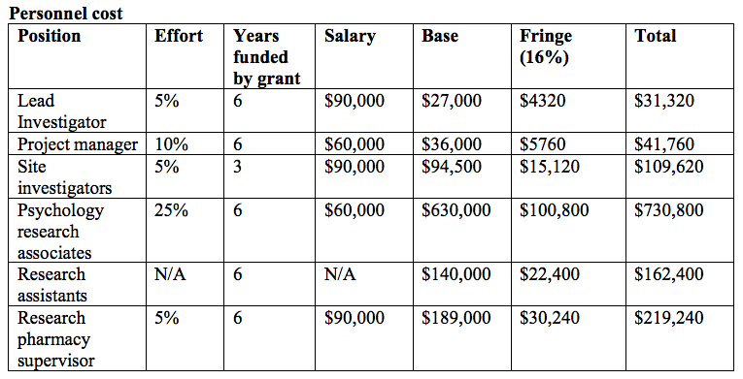

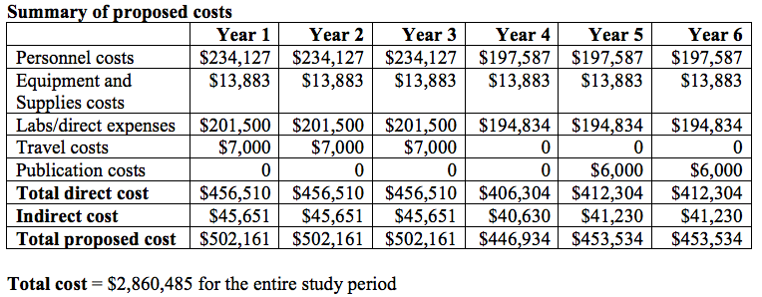

11 References

1. Castillejos MC, Martín-Pérez C, Moreno-Küstner B. Incidence of psychotic disorders and its association with methodological issues. A systematic review and meta-analyses. *Schizophr Res*. 2019;204:458-459. doi:10.1016/j.schres.2018.07.031

2. Charlson FJ, Ferrari AJ, Santomauro DF, et al. Global epidemiology and burden of schizophrenia: Findings from the global burden of disease study 2016. *Schizophr Bull*. 2018;44(6):1195-1203. doi:10.1093/schbul/sby058

3. Hjorthøj C, Stürup AE, McGrath JJ, Nordentoft M. Years of potential life lost and life expectancy in schizophrenia: a systematic review and meta-analysis. *The Lancet Psychiatry*. 2017;4(4):295-301. doi:10.1016/S2215-0366(17)30078-0

4. Hui C, Morcillo C, Russo DA, et al. Psychiatric morbidity, functioning and quality of life in young people at clinical high risk for psychosis. *Schizophr Res*. 2013;148(1-3):175-180. doi:10.1016/j.schres.2013.05.026

5. Addington J, Penn D, Woods SW, Addington D, Perkins DO. Social functioning in individuals at clinical high risk for psychosis. *Schizophr Res*. 2008;99(1-3):119-124. doi:10.1016/j.schres.2007.10.001

6. Malla A, Payne J. First-episode psychosis: Psychopathology, quality of life, and functional outcome. *Schizophr Bull*. 2005;31(3):650-671. doi:10.1093/schbul/sbi031

7. Tze C, Kam K, Chang WC, et al. Patterns and predictors of trajectories for subjective quality of life in patients with early psychosis : Three-year follow- up of the randomized controlled trial on extended early intervention. 2021;00(0). doi:10.1177/00048674211009603

8. Bird V, Premkumar P, Kendall T, Whittington C, Mitchell J, Kuipers E. Early intervention services, cognitive-behavioural therapy and family intervention in early psychosis: Systematic review. *Br J Psychiatry*. 2010;197(5):350-356. doi:10.1192/bjp.bp.109.074526

9. Breitborde NJK, Srihari VH, Woods SW. Review of the operational definition for first-episode psychosis. *Early Interv Psychiatry*. 2009;3(4):259-265. doi:10.1111/j.1751-7893.2009.00148.x

10. Malla A, McGorry P. Early intervention in psychosis in young people: A population and public health perspective. *Am J Public Health*. 2019;109:S181-S184. doi:10.2105/AJPH.2019.305018

11. Fusar-Poli P, de Micheli A, Patel R, et al. Real-World clinical outcomes two years after transition to psychosis in individuals at clinical high risk: Electronic health record cohort study. *Schizophr Bull*. 2020;46(5):1114-1125. doi:10.1093/schbul/sbaa040

12. Fusar-Poli P. The Clinical High-Risk State for Psychosis (CHR-P), Version II. *Schizophr Bull*. 2017;43(1):44-47. doi:10.1093/schbul/sbw158

13. Yung AR, Yuen HP, McGorry PD, et al. Mapping the onset of psychosis: the Comprehensive Assessment of At-Risk Mental States. *Aust N Z J Psychiatry*. 2005;39(11-12):964-971. doi:10.1111/j.1440-1614.2005.01714.x

14. Stafford MR, Jackson H, Mayo-Wilson E, Morrison AP, Kendall T. Early interventions to prevent psychosis: Systematic review and meta-analysis. *BMJ*. 2013;346(7892):1-13. doi:10.1136/bmj.f185

15. Davies C, Radua J, Cipriani A, et al. Efficacy and acceptability of interventions for attenuated positive psychotic symptoms in individuals at clinical high risk of psychosis: A network meta-analysis. *Front Psychiatry*. 2018;9(JUN). doi:10.3389/fpsyt.2018.00187

16. Raballo A, Nelson B, Thompson A, Yung A. The Comprehensive Assessment of At-Risk Mental States: From mapping the onset to mapping the structure. *Schizophr Res*. 2011;127(1-3):107-114. doi:10.1016/j.schres.2010.12.021

17. Demjaha A, Valmaggia L, Stahl D, Byrne M, McGuire P. Disorganization/cognitive and negative symptom dimensions in the at-risk mental state predict subsequent transition to psychosis. *Schizophr Bull*. 2012;38(2). doi:10.1093/schbul/sbq088

18. Maneeton N, Maneeton B, Woottiluk P, et al. Quetiapine monotherapy in acute treatment of generalized anxiety disorder: A systematic review and meta-analysis of randomized controlled trials. *Drug Des Devel Ther*. 2016;10:259-276. doi:10.2147/DDDT.S89485

12 Appendices - Appendix I: Study Schema

*Screening*

CAARMS, EKG, Medical record review, Eligibility interview including word reading test, substance use assessment, and suicidality assessment



*Enrollment/Baseline*

Anthropometrics including Physical Exam, Family & Medical History, Vitals, PANSS,

EKG (if needed), Serum metabolic and thyroid panels, SF-36, PHQ-9, GAD-7,

Adherence Assessment (pill count)



*1-Month Assessment*

Anthropometrics including Physical Exam, Vitals, PANSS, Serum metabolic and thyroid panels, Adherence assessment (pill count), Adverse events



*2-Month Assessment*

Anthropometrics including Physical Exam, Vitals, PANSS, Serum metabolic and thyroid panels, Adherence assessment (pill count), Adverse events



*3-Month Assessment*

Anthropometrics including Physical Exam, Vitals, PANSS, Serum metabolic and thyroid panels, SF-36, PHQ-9, GAD-7, Adherence assessment (pill count), Adverse events,



*Monthly after 3-Month Assessment*

PANSS, Vitals, Adherence assessment (pill count), Adverse events



*3-Month visits only (e.g. Months 6, 9, 12, etc)*

Anthropometrics including Physical Exam, Serum metabolic and thyroid panel, SF-36, PHQ-9, GAD-7

Appendix II: Informed Consent

**Informed Consent Form**

**Consent From Age 18 and Up**

*Study Title:* **Evaluating Low-Dose Quetiapine in the Prevention of Transition to Psychosis in Severe Clinical High-Risk Individuals:**

**A randomized, Double-blind, Placebo-Controlled Trial**

**Principal Researcher: Warren Szewczyk, BA**

**The Research Team**

|  |  |  |  |  |
| --- | --- | --- | --- | --- |
| **Name** | **Title** | **Department** | **Phone-Number** | **Email** |
| **Szewczyk, Warren** | **Principal Investigator** | **Epidemiology** | **573-881-6616** | **warrenjs@uw.edu** |
| **Wu, Natalie** | **Co-Investigator** | **Epidemiology** | **425-802-2527** | **nataliel@uw.edu** |
| **Zhang, Ivy** | **Co-Investigator** | **Biostatistics** | **206-317-9863** | **yuez9@uw.edu** |
| **Li, Qin** | **Co-Investigator** | **Biostatistics** | **413-406-8423** | **qqinli@uw.edu** |
| **Fleming, Thomas** | **Professor** | **Biostatistics** | **206-543-8026** | **tfleming@uw.edu** |
| **Bannick, Marlena** | **TA/Consulting** | **Biostatistics** | **206-498-0046** | **mnorwood@uw.edu** |

1. **Researcher’s Statement:**

You have the option to take part in a research study. This form will give you information about what would happen if you choose to take part in the study and to help you decide if you want to be in the study. Participation is completely voluntary.

If you would like to take notes or write down questions, we can provide you with a separate piece of paper to do so.

1. **What you should know about this study:**

* This form explains what would happen if you join this research study.
* Please read it carefully. Take as much time as you need.
* Please ask the research team questions about anything that is not clear.
* You can ask questions about the study at any time.
* Half of the study participants will receive the active drug under study. The other half of the participants will receive an inactive pill made to look like the drug under study. This is called a “placebo”.
* Whether you receive the active drug or the placebo is *random* -- You will have a 50% chance to receive the active drug.
* All participants, whether receiving active drug or placebo, will be
* If you choose not to be in the study, it will not affect your care within the Kaiser Permanente health system.
* If you receive healthcare outside of Kaiser Permanente, you may still participate in this study.
* If you say ‘Yes’ to participate now, you can still change your mind later.
* You can quit the study at any time.
* You will not lose benefits or be penalized if you decide not to take part in the study or to quit the study later.

1. **What is the goal of this study?**

Our research team is completing this research study to answer two questions:

* Can a low dose of a medication called *quetiapine* (keh-TIE-ah-peen) help prevent psychosis for people who may be at high risk for psychosis?
* Can a low dose of quetiapine help improve the quality of life for people who may be at high risk for psychosis?

1. **Why do I have the option of joining the study?**

You have the option to take part in this research study because a clinical assessment at screening determined you may be at high risk of developing psychosis within the next 1-3 years. We would like to create better treatments for people in your situation.

1. **How many people will take part in the study?**

We expect roughly 340 people will take part in this research study.

1. **If I agree to join this study, what would I need to do?**

Day 0 - “Baseline” Visit

If you join the study, we will ask you to begin with several non-invasive medical tests to ensure that taking quetiapine is likely to be safe for you. These tests would include a blood draw and electrocardiogram (EKG). See below for more details on these procedures. We would ask you to complete a basic physical exam with a doctor and answer questions about your personal medical history and your family’s medical history. An interviewer will ask you about mental health symptoms, if any, you have been experiencing over the past month and you would be asked to complete several survey questionnaires.

Randomization

After finishing all the procedures to be enrolled in the study, you will be assigned to either receive quetiapine or a “placebo” pill. The placebo pill is nearly identical to quetiapine, except it does not have any active drug.

You have an equal chance (50/50) of being assigned to either quetiapine or placebo, and this determination is random, like flipping a coin. You will not be aware which pill you are receiving. Also, the study staff and the people who run the study will not be aware which pill you are receiving.

Once you are randomized, you will receive instructions for obtaining your study medication. You will be asked to take the study medication every day, with instructions for how and when to take the medication.

Explanation of Research Tests to Procedure:

In addition to taking the assigned pills every day, we would ask you to come to clinic visits for research related tests and exams. All the required visits are listed in the chart below.

These tests and exams help us to find out if being in this study causes any effects that are important to know about. We use them to check on the safety of people in the study. We also use them to learn if the treatment is helping or not.

**Vitals:** *All visits.* A research nurse will collect standard medical vital signs such as heart rate (pulse), blood pressure, height, weight, and waist circumference among others.

**Blood draw:** *Day 0, Month 1, Month 2, Month 3, every 3 months after Month 3.* A trained and licensed research nurse or phlebotomist will obtain several vials of blood. Each vial will be less than 5 milliliters (mL), and the total amount of blood drawn will be less than 50 mL.

**EKG:** *Day 0, Month 1, Month 2, Month 3, every 3 months after Month 3.* An electrocardiogram (EKG) will be performed by a trained and licensed cardiologist or nurse in a professional clinical setting. Electrodes that record electrical activity will be placed on the skin of your chest and will measure the electrical activity of the heart.

**Interview:**

PANSS: *All visits.* The Positive and Negative Symptom Scale (PANSS) will ask questions about symptoms of psychosis, such as hearing voices or lacking motivation. A trained and licensed psychologist or mental health professional will conduct an interview to complete the PANSS.

**Survey questionnaires:**

SF-36: *Day 0, every three months.* The Short Form Health Questionnaire (SF-36) will ask questions about your general well-being over the past 3 months.

PHQ-9: *Day 0, every three months.* The Patient Health Questionnaire (PHQ-9) will ask about symptoms of depression you may be experiencing.

GAD-7: *Day 0, every three months.* The Generalized Anxiety Disorder questionnaire (GAD-7) will ask questions about symptoms of anxiety you may be experiencing.

Medications: *Day 0.* You will be asked about current and past medication usage.

Safety (Adverse Events): *Every month.* You will be asked questions about your general health to identify any negative effects of participating in the study. This information will be used to ensure you are safe during the conduct of this study.

Research Study Visits:

|  |  |  |
| --- | --- | --- |
| Visit Schedule | Procedures | Approx Time |
| Day 0 (“Baseline”) | Vitals  Medical History  Physical Exam  Blood Draw  EKG  Interviews  Symptom surveys  Randomization | 3 hours |
| Month 1 and Month 2 | Vitals  Physical Exam  Blood Draw  Interview  Symptom/Safety surveys  Pill Count | 2 hours |
| Every three months, starting with Month 3 | Vitals  Physical Exam  Blood Draw  Interviews  Symptom and Safety Surveys  Pill Count | 2 hours |
| Each month after Month 3 | Vitals  Interview  Pill Count  Safety Surveys | 1 hour |

1. **How long would I be in the study?**

If you choose to take part in all the study visits, you would be in the study for 36 months (3 years).

If you join the study, you can decide to stop at any time for any reason. If you decided to stop, you would need to talk to **Natalie Wu** so you leave the study in a safe way.

The research study doctor could also decide to take you out of the study. This might happen if we find out that it is not safe for you to stay in the study. Or it might happen if you cannot come to enough of the study visits, or if you cannot follow the study schedule. If we ask you to leave the study, we would always explain why.

1. **What are the potential harms or risks if I join this study?**

There are potential harms or risks if you take part in this study. Some are common and some are rare. These are decided below.

Common side effects of quetiapine (>5% incidence) include:

* Daytime drowsiness
* Increased sleep hours
* Dizziness
* Dry mouth
* Constipation
* Serum glutamic pyruvic transaminase elevation
* Weight gain
* Dyspepsia/indigestion
* Tachycardia
* Agitation

Less common side effects (<5% incidence) include:

* Rash
* Somatic pain
* Gastroenteritis
* Pharyngitis
* Rhinitis
* Decreased sexual arousal
* Decreased orgasm
* Gynecomastia
* Urinary hesitancy
* Incontinence or nocturia
* Galactorrhea
* Sialorrhea
* Akathisia
* Akinesia
* Insomnia
* Menstrual irregularities
* Decreased sex drive

Because this research study involves an experimental medication, we do not know all of the possible risks or harms.

A Data and Safety Monitoring Board will review the information from this research study. This board is made of a group of experts. They are responsible for looking at how people in the research study are doing. If you take part, we would tell you about any new information we learn that might affect your health or your willingness to stay in the study.

1. **What are the potential benefits if I join this study?**

We are evaluating whether quetiapine is beneficial to people at high risk of developing psychosis. It is currently unknown whether it is beneficial. Therefore, we do not promise any benefit by taking part in this trial. However, there may be potential benefits to participating.

Being in the study might benefit you in the following ways:

* A baseline (Day 0) evaluation including physical examination events will be conducted to you.
* Monthly follow-up sessions will be conducted to the participants, so you are able to take PANSS monthly and several physical examinations.

Potential benefits for Others:

We hope to use the information we get from this study to benefit others who are defined as severe clinical high-risk of psychosis.

1. **What other options do I have?**

If you choose not to be in this study. You can

* Continue normal treatment inside Kaiser Permanente health system

Please talk to your doctor or the research team about these options.

1. **How would you keep my information confidential?**

**If you take part, we will make every effort to keep your information confidential.**

We will store all of your research records and information in locked cabinets and secure computer files. We will not put your name on any research data. Instead, we will label your information with a study number. The master list that links a person’s name to their study number is stored in a locked cabinet or on a secure computer file.

If results of this research are published, we would not use information that we may need to share the information you give us with others:

* If it’s required by law.
* If we think, you or someone else could be harmed.
* Sponsors, government agencies, or research staff sometimes look at forms like this and other study records. They do this to make sure the research is done safely and legally. Anyone who reviews study records would keep your information confidential.
  + Agencies or sponsors that may look at study records include:
    - The US Food and Drug Administration (FDA)
    - Hospital Auditors
    - Government Agencies
    - Other responsible for watching over the safety, effectiveness, and conduct of the research.

If you join this study, we would put information about this study in your medical record. We do this because the research study involves patient care.

We will keep your results until December 31, 2031.

1. **Would it cost me money to be in the study?**

If you take part in this study, there would be no cost to you and no cost to your insurance company.

1. **What if I were injured or ill because I joined the study?**

If you were injured or ill as the direct result of this research study. Kaiser Permanente health system would provide treatment. We would refer you for treatment if needed.

You would NOT need to pay for this treatment and neither would your insurance company. This is the only compensation offered for study-related injuries. It is important that you tell the Principal Researcher Warren Szewczyk, if you think that you have been injured because of taking part in this study. You can call him/her at 573-881-6616

1. **Would I be paid if I join this study?**

We thank you for your help with this study for each study visit, but there will be no payments to you in this research study.

1. **Who do I contact if I have problems, questions or want more information?**

|  |  |  |
| --- | --- | --- |
| **If I have questions or would like to know about** | **I can call** | **At** |
| * Emergencies * General study questions * Any research-related concerns or complaints | **Szewyck, Warren** | 573-881-6616 |
| * Emergencies * Research-related injuries | **Wu, Natalie** | 425-802-2527 |
| * Emergencies * General study questions * Any research-related concerns or complaints | **Zhang, Ivy** | 206-317-9863 |
| * Emergencies * General study questions * Any research-related concerns or complaints | **Li, Qin** | 413-406-8423 |
| Your right as a research participant | **Institutional Review Board** | 206-987-7804 |

**More Information:**

A description of this clinical trial will be available on [http://www.ClinicalTrial.gov](http://www), as required by U.S. Law. This website will not include information that can identify you. At most, the website will include a summary of the results. You can search this website at any time.

1. **If I join the study, can I stop?**

Yes. Taking part in this study is always a choice. If you decide to be in the study, you can change your mind at any time. We ask that you tell Natalie Wu. To reach her, please call 425-802-2527

If you choose to leave the study, it will not affect your care atKaiser Permanente health system**.** You will not lose any benefits or be penalized if you choose to leave the study.

1. **What would my signature on this form mean?**

Your signature on this form would mean:

* The research study was explained to you.
* You had a chance to ask all the questions you have at this time. All your questions have been answered in a way that is clear.
* You understand that the persons listed on this form will answer any other questions you may have about the study or your rights as a research study participant.
* You have rights as a research participant. We will tell you about new information change to the study that may affect your health or your willingness to stay in the study.
* By signing this consent form, you do not give up any of your legal rights. The researcher(s) or sponsor(s) are not relieved of any liability they may have.
  + You agree to take part in this research study.

_________________________________________________________________________

Printed Name of Research Participant

_________________________________________________________________________

Signature of Research Participant

_____________ ________________

Date Time

1. **Researcher’s Signature**

I have fully explained the research study described by this form. I have answered all questions from participants and will answer any future questions to the best of my ability. I will tell the participant taking part in this research of any changes in the procedures or in the possible harms/possible benefits of the study that may affect their health or their willingness to stay in the study.

____________________________________________________________________________

Printed Name of Researcher Obtaining Consent

____________________________________________________________________________

Signature of Researcher Obtaining Consent

__________________ __________________

Date Time

1. **Interpreter Information**

________________________________________________________________________

Printed Name of Interpreter during initial presentation of study

_________________________________________________________________________

Printed Name of Interpreter when translated form is presented(if applicable)

1. **Witness Information for Short Form Use**

**I have been present during the verbal presentation of this research study.**

_____________________________________________________________

Printed Name of Witness

_____________________________________________________________

Signature of Witness

__________________ __________________

Date Time

Original form to:

Research Team File

Copies to:

Participant

Medical Records(if applicable)

Appendix III: PANSS

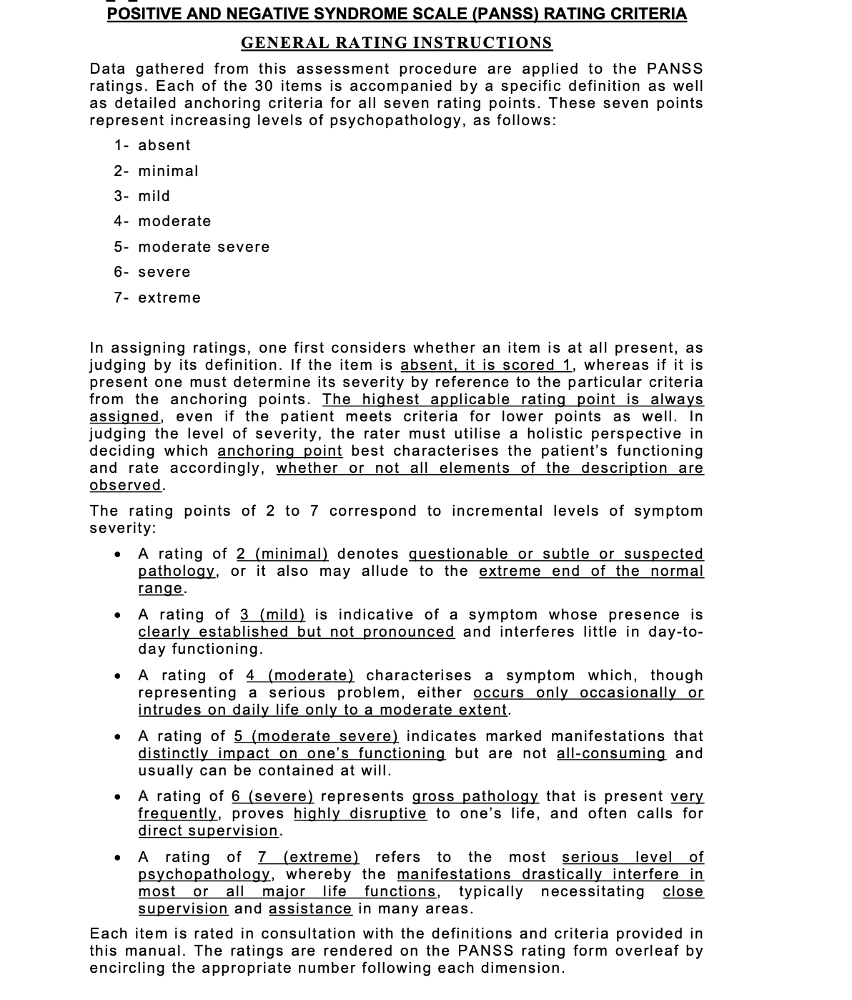

* 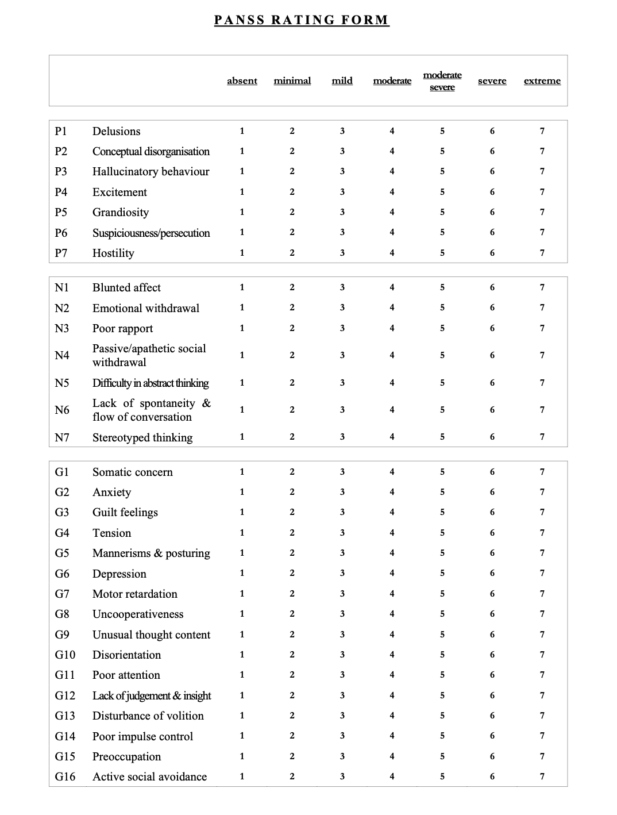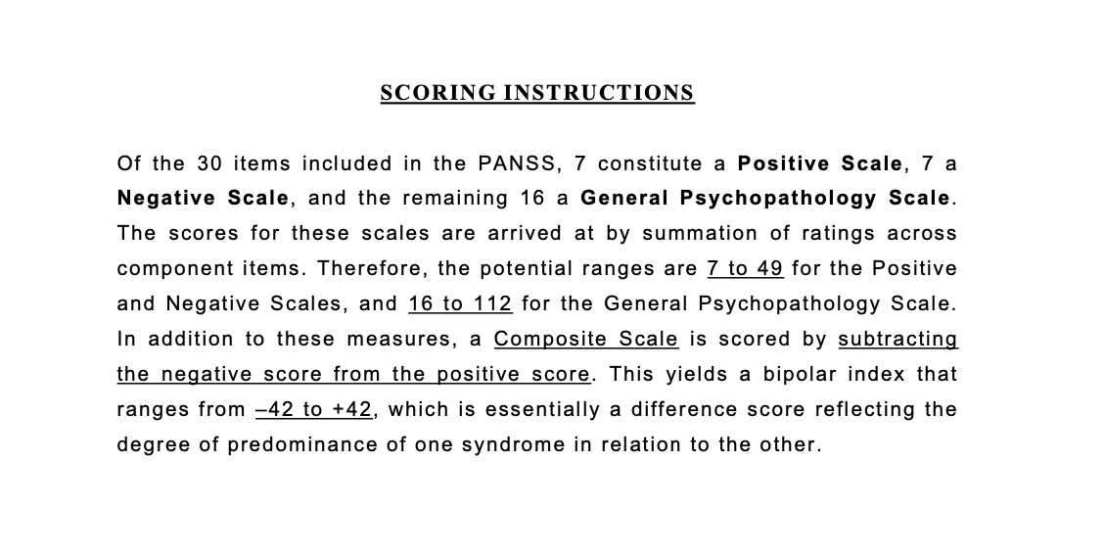
* 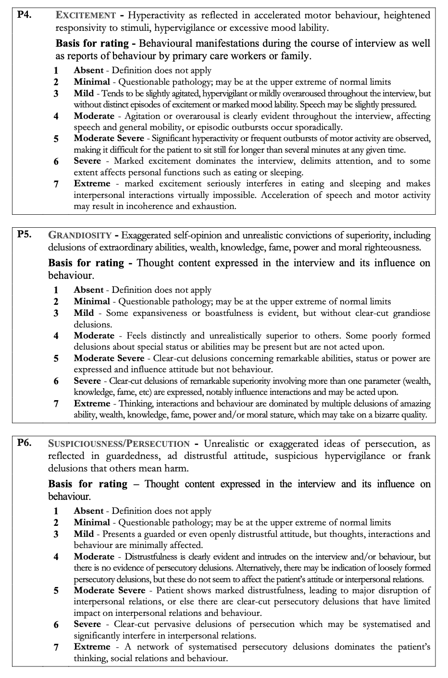
* 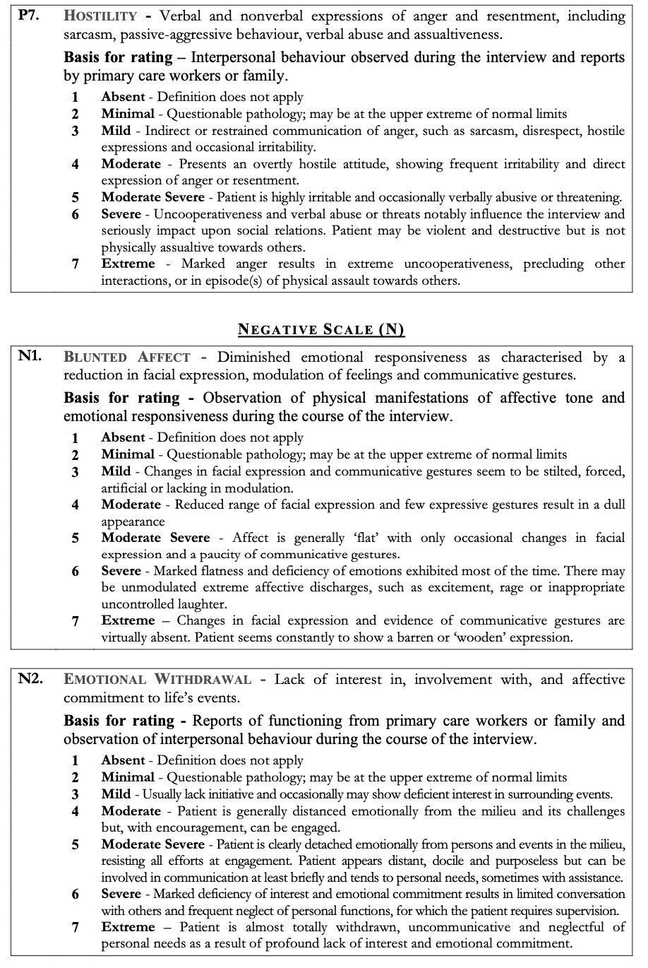
* 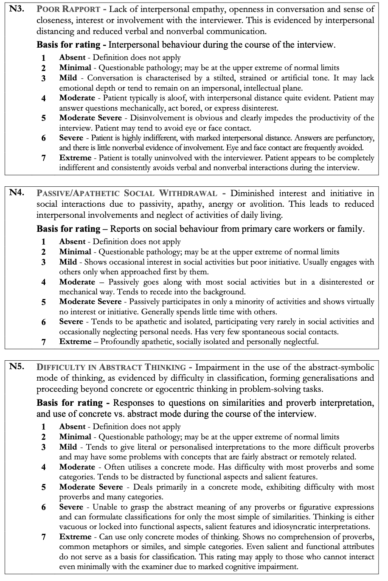
* 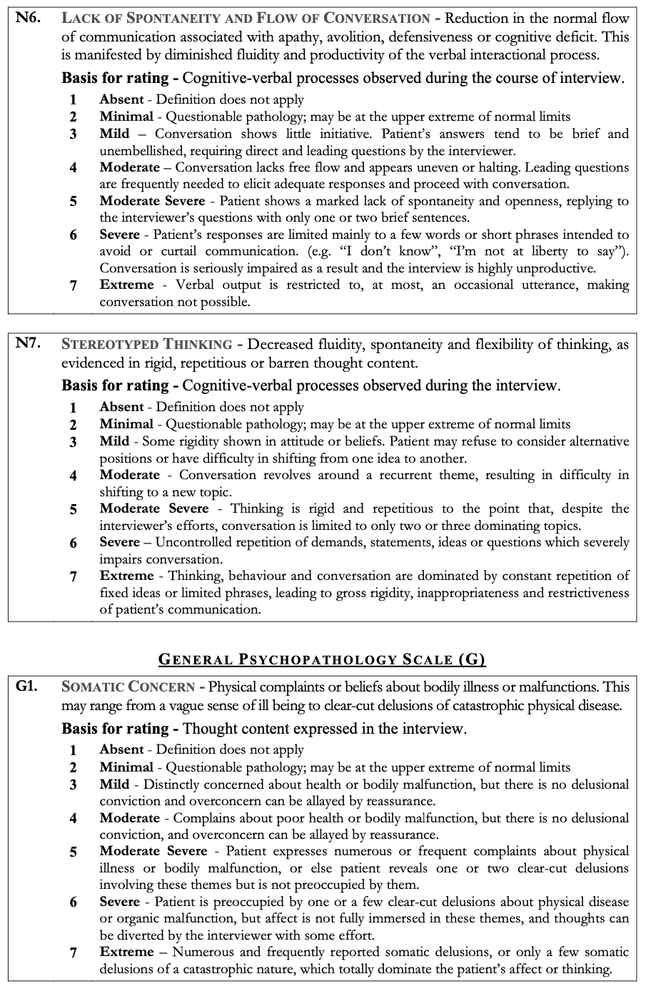
* 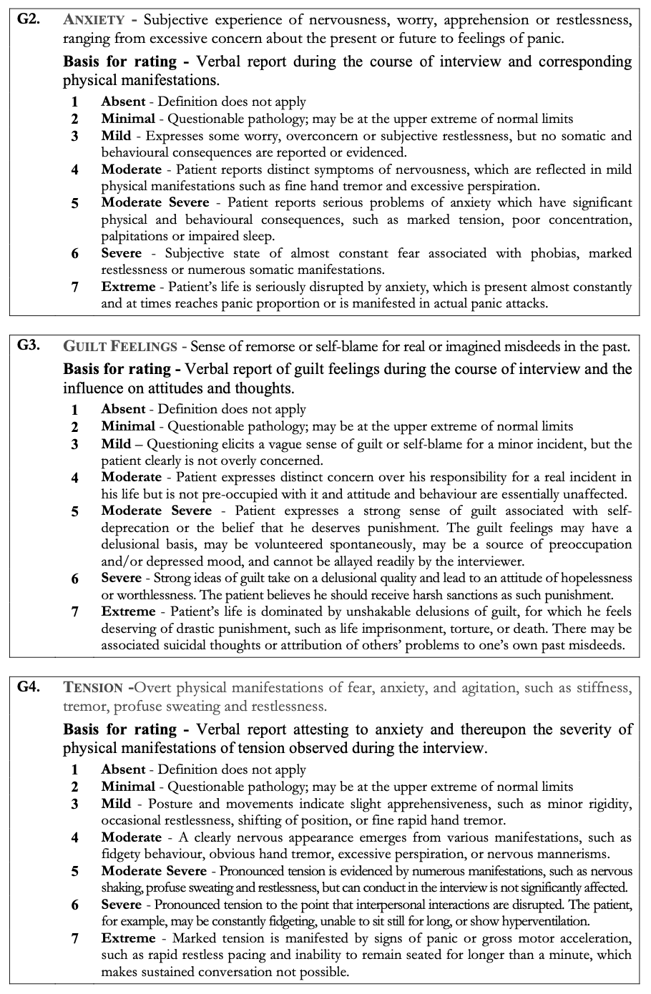
* 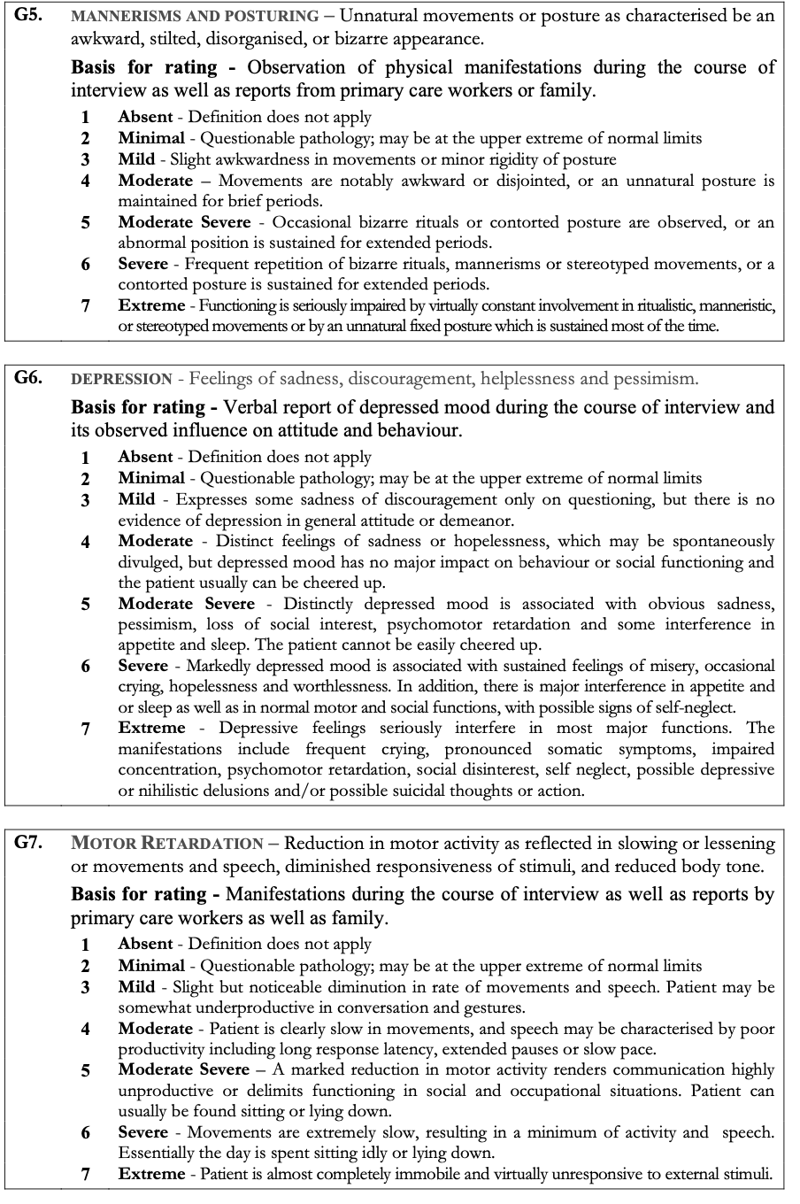
* 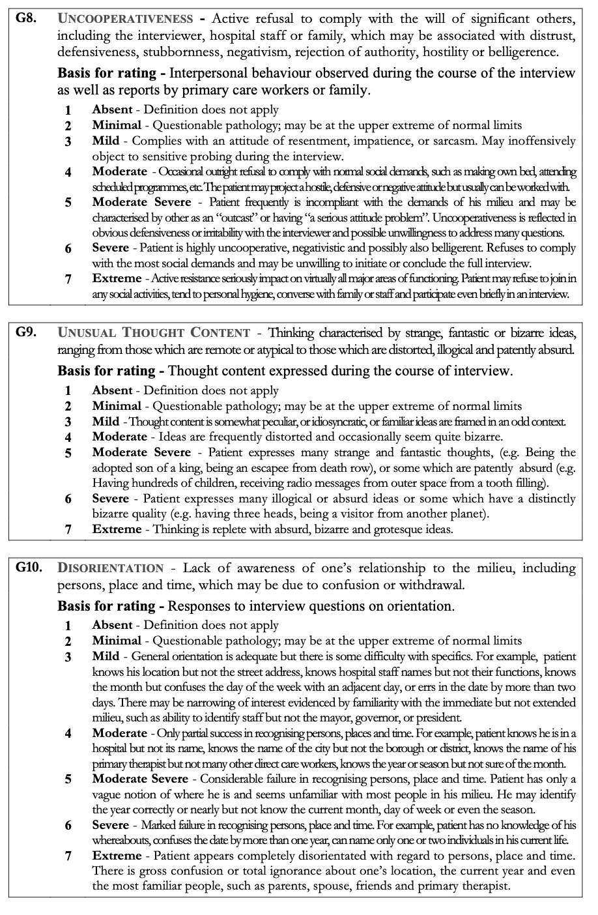
* 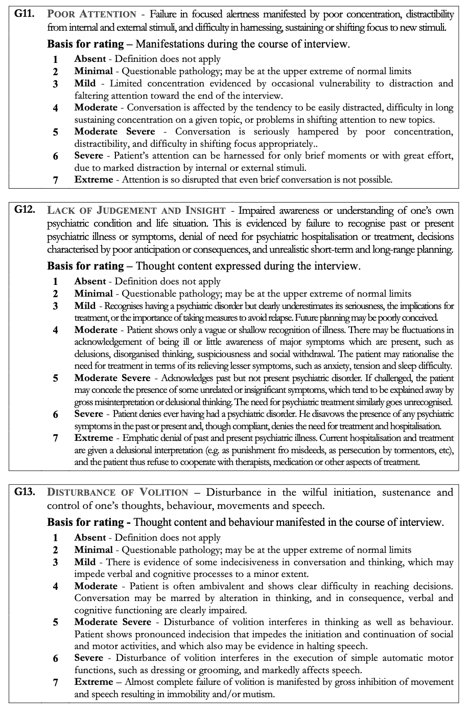
* 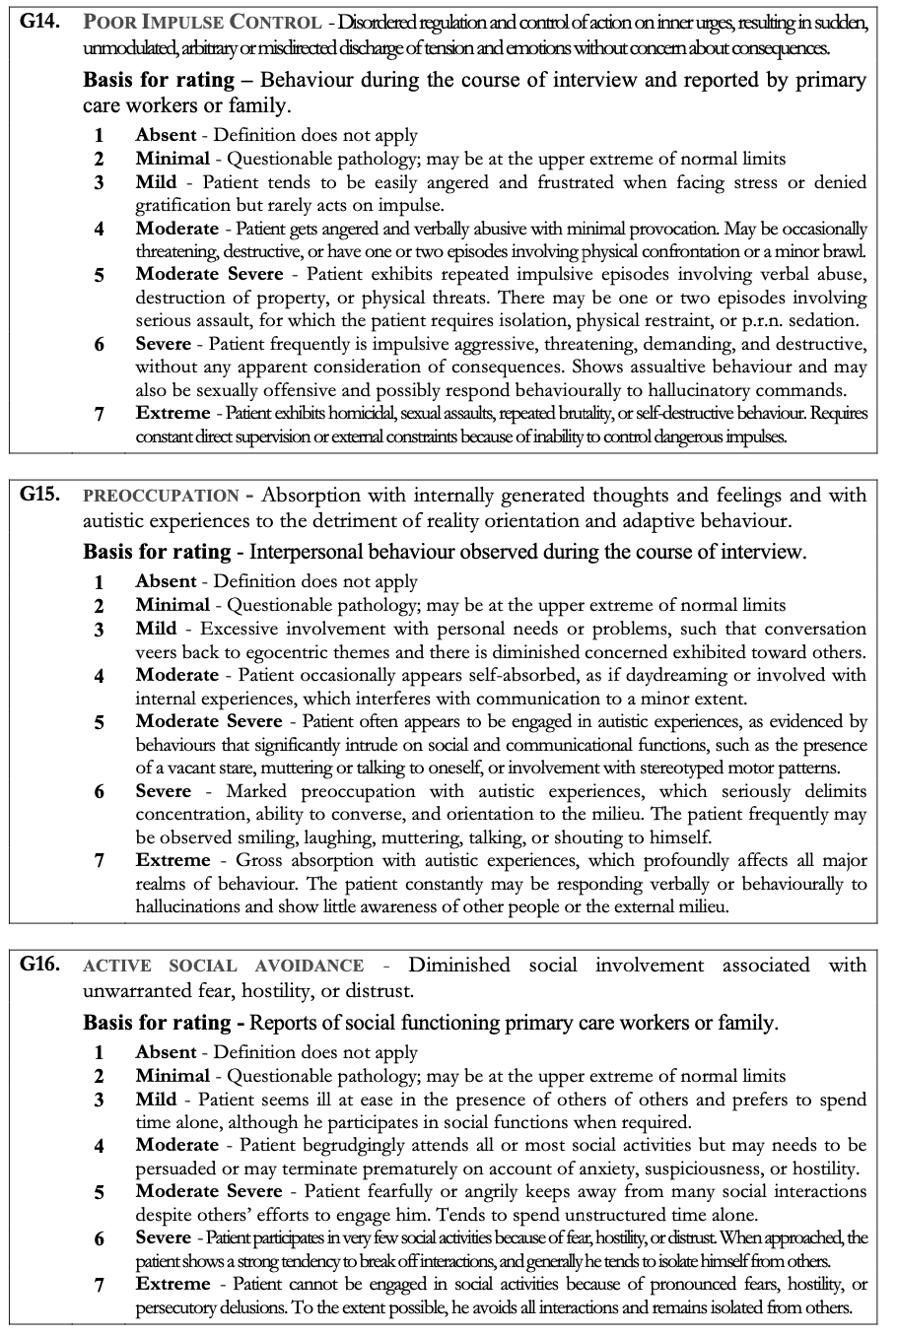

Appendix IV: Barnes-Akathisia Rating Scale(BARS)

* 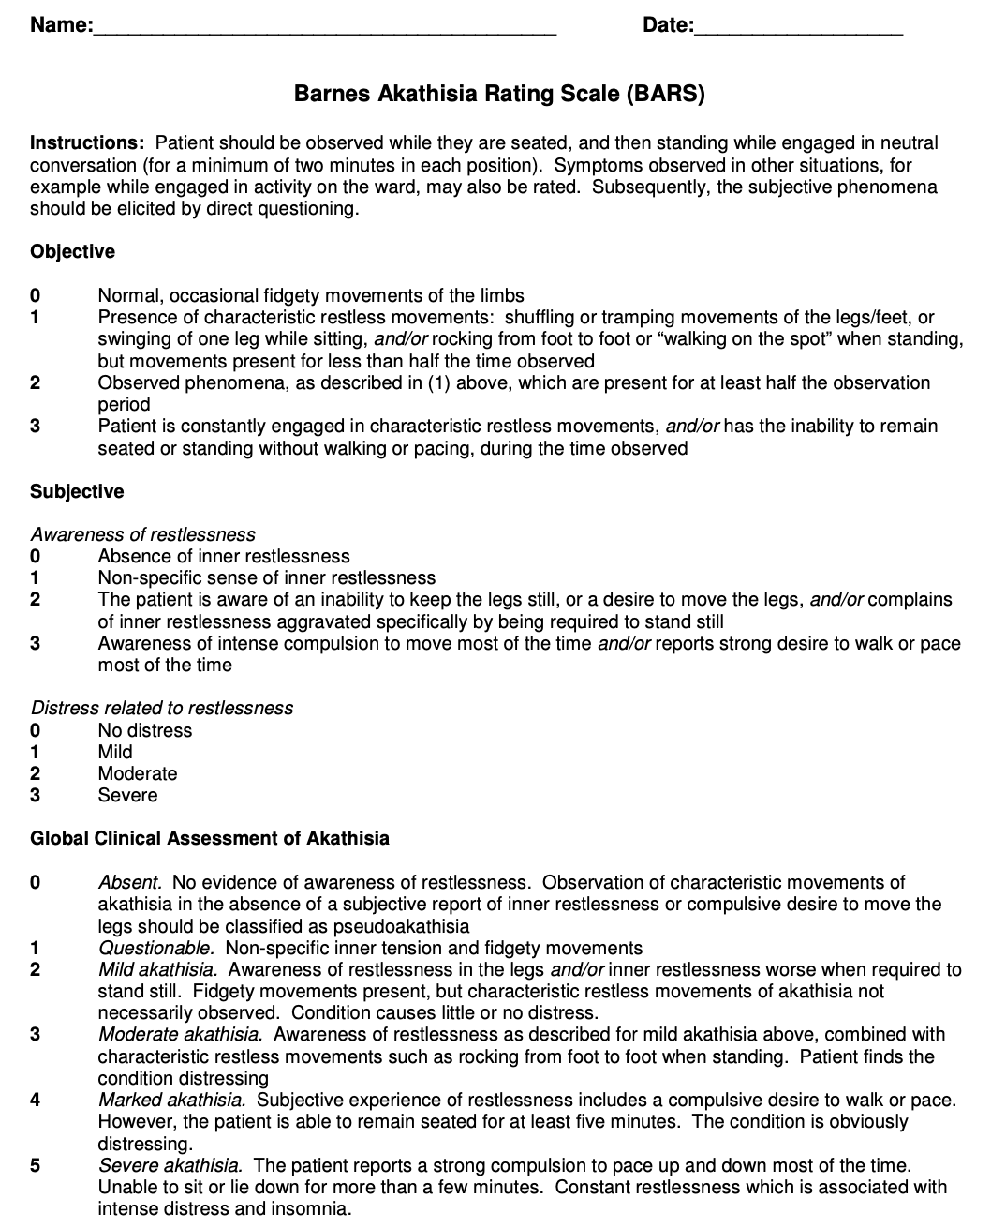



Appendix V: Abnormal Involuntary Movement Test (AIMS)

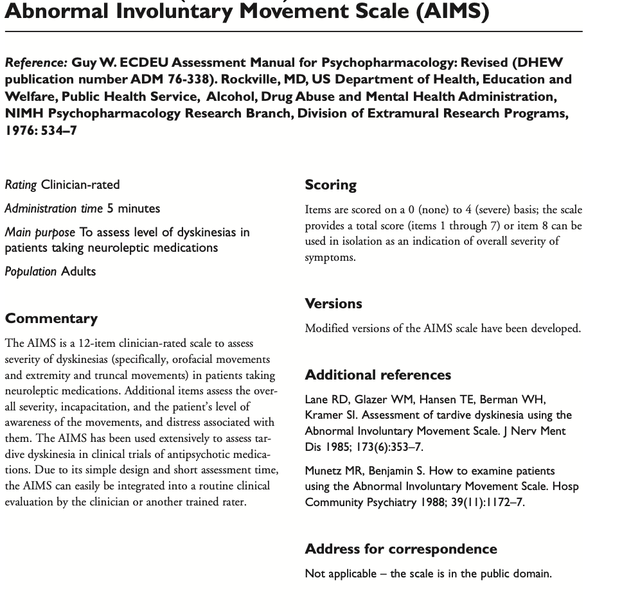

Appendix VI:Simpson Angus Scale



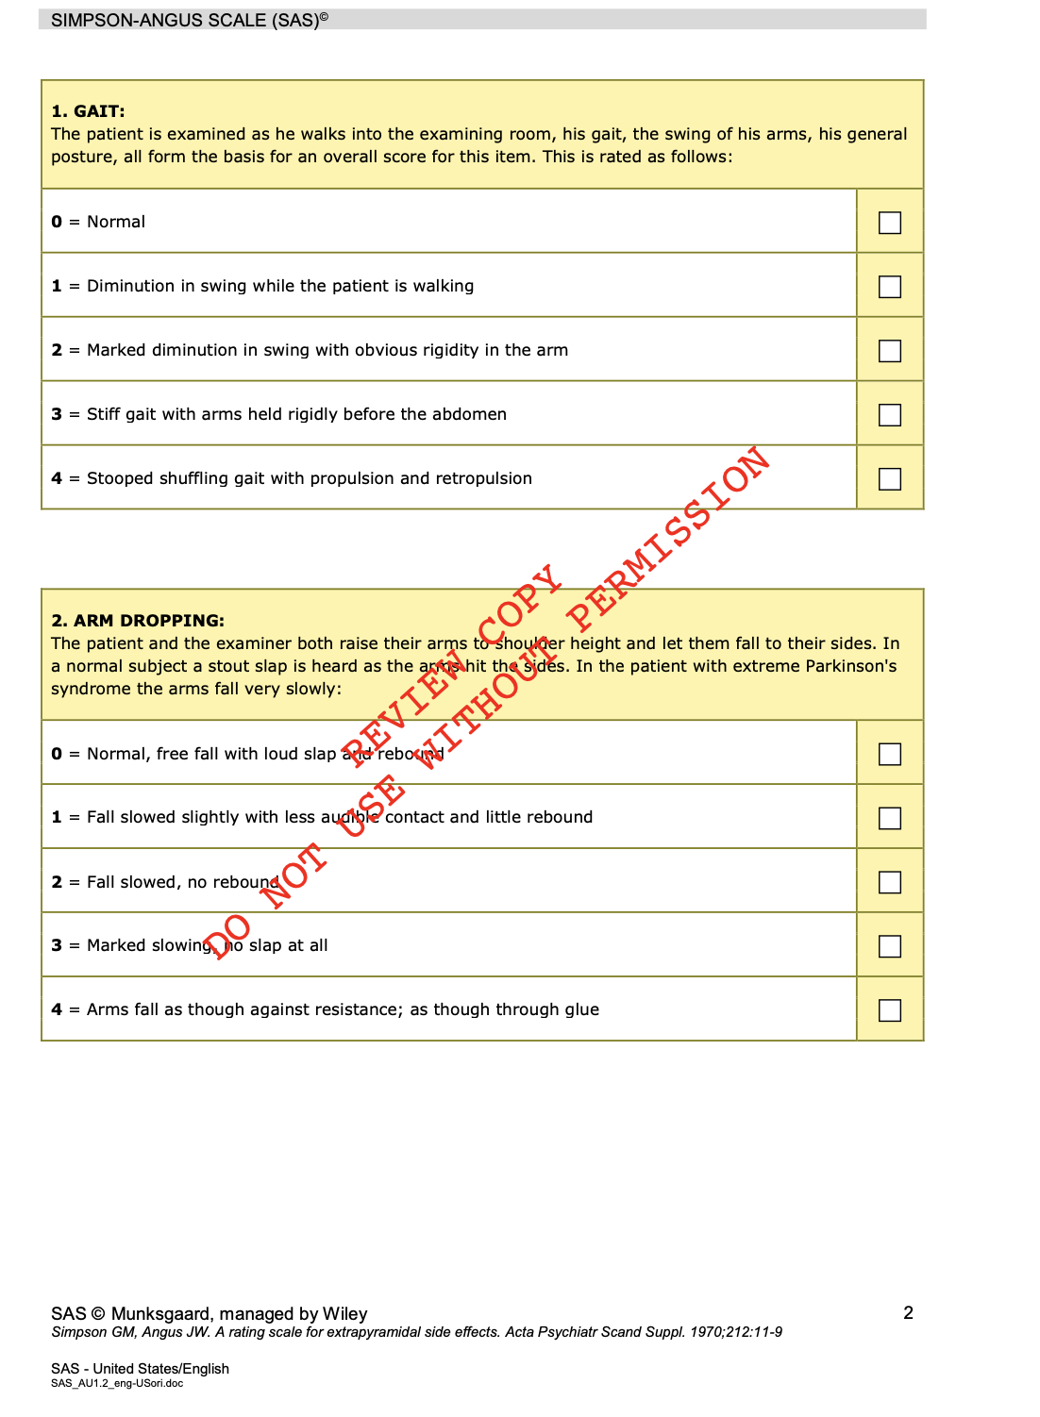

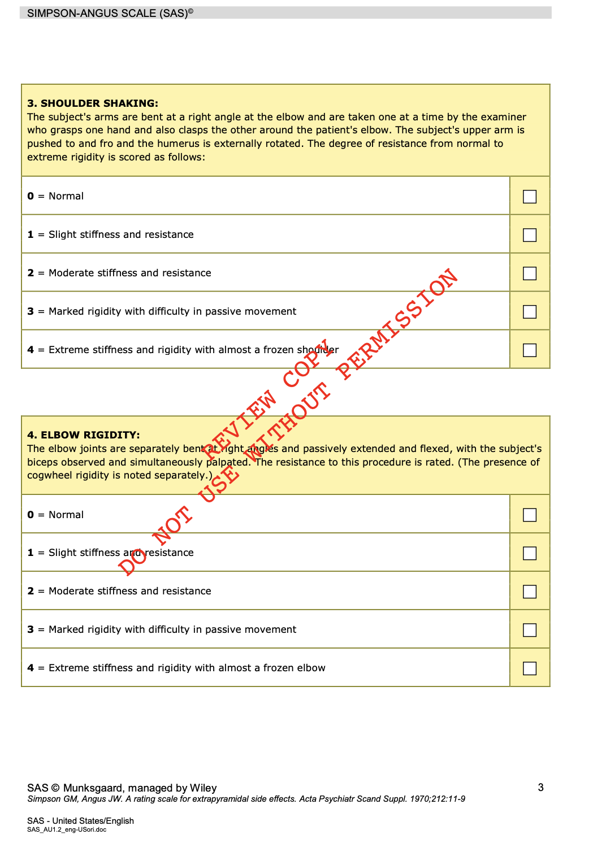

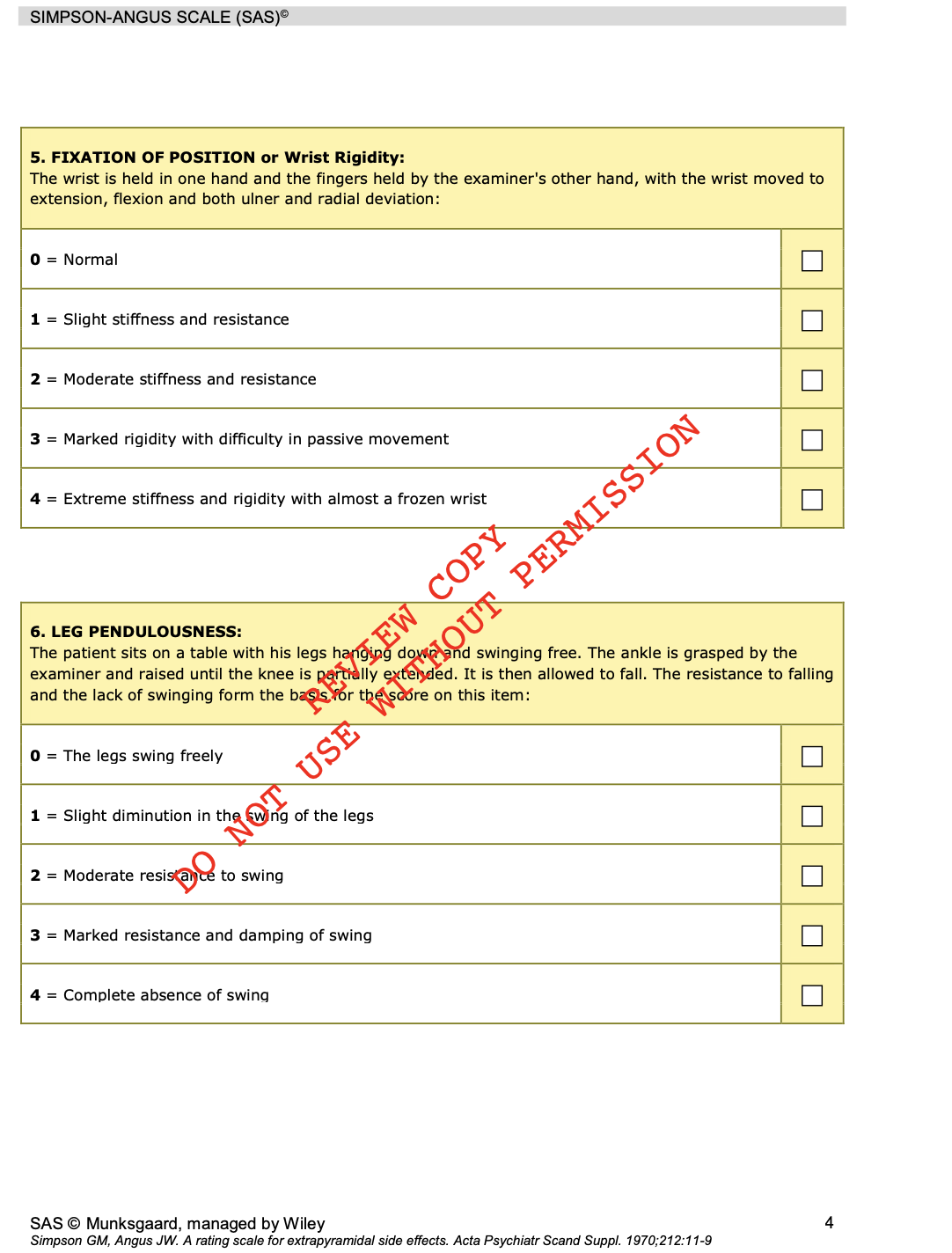

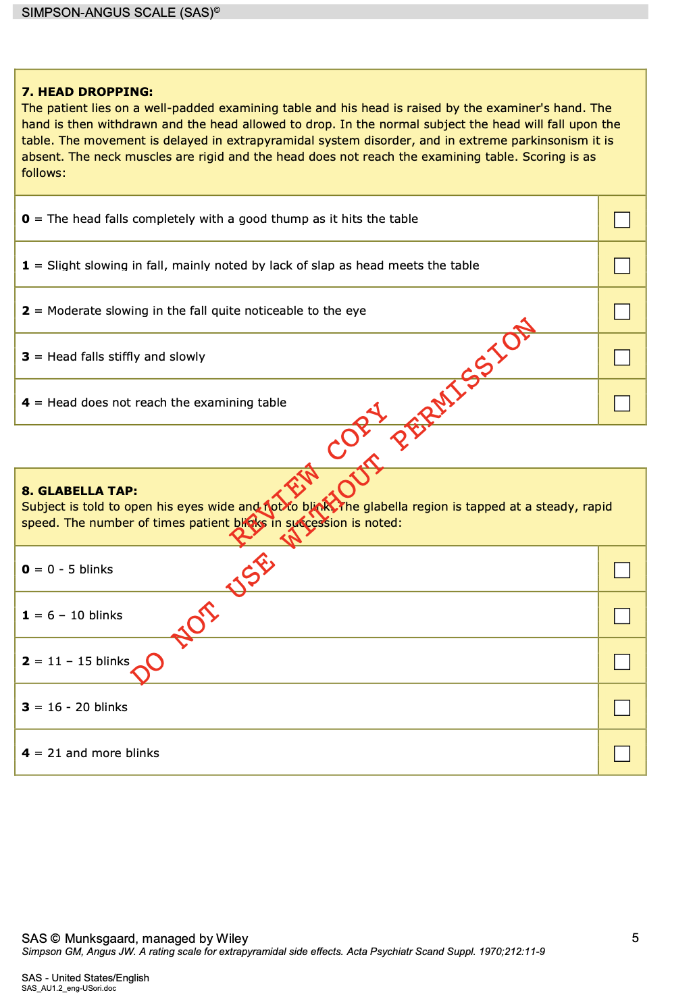

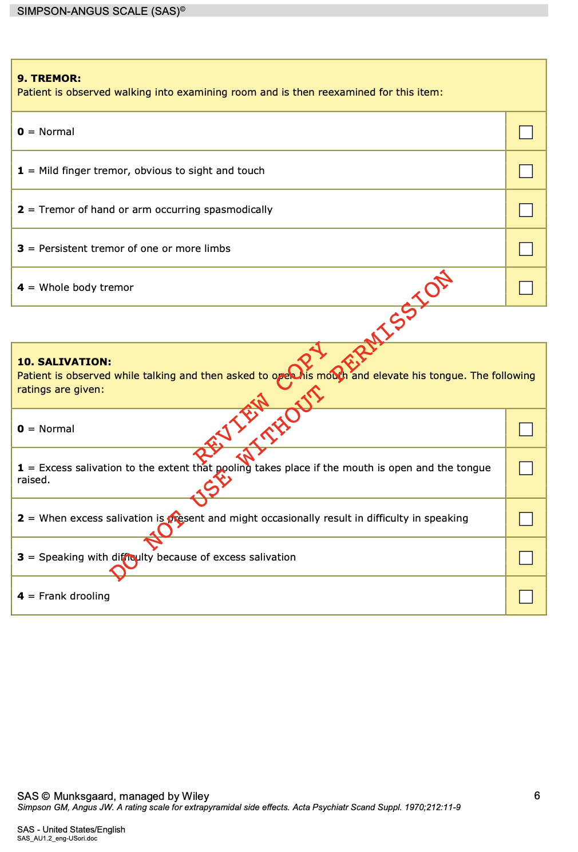

Appendix VII: Udvalg for Kliniske Undersøgelser scale

